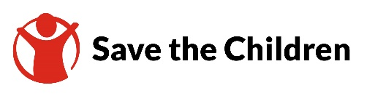
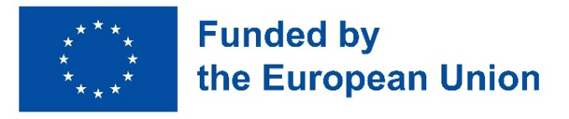

Quality Education - Leaving No One Behind

INTERIM NARRATIVE REPORT

1st March 2024 to 28th February 2025

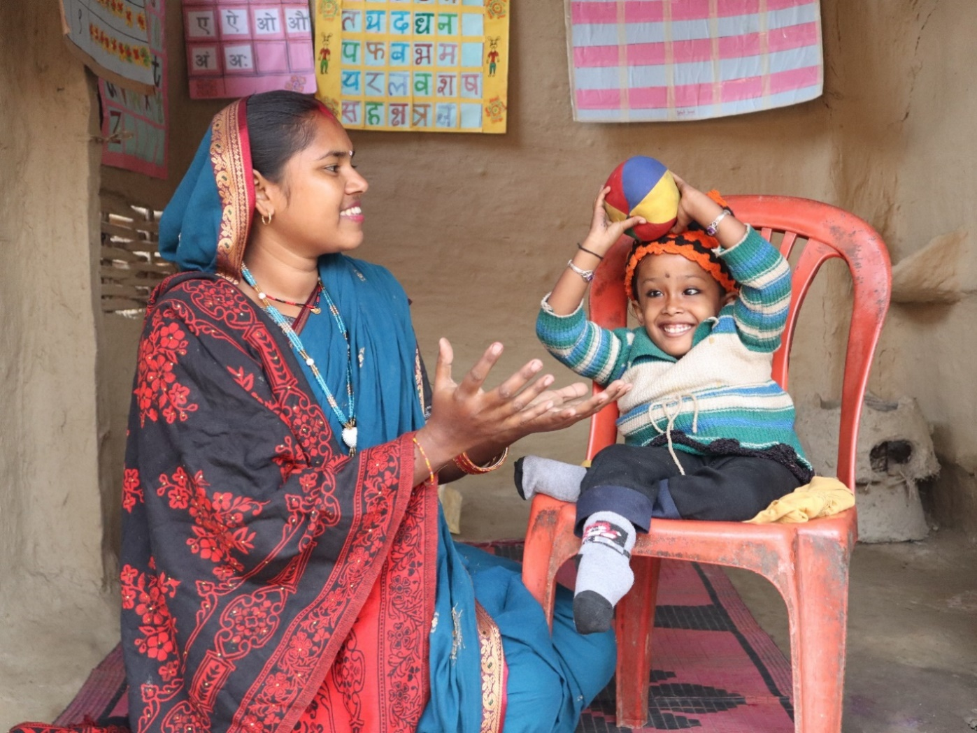

Save the Children, Nepal and Bhutan Country Office
14 May 2025

Table of contents Page number

- Description……………………………………………………………………………………………………………………5
- Assessment of the implementation of the action activities and its results…………………….6
  - Executive summary of the action…………………………………………………………………………………6
  - Results and activities…………………………………………………………………………………………………...7
  - Logframe matrix updated………………………………………………………………………………………….31
  - Activity Matrix………………………………………………………………………………………………………… 35
  - Updated action plan for the future activities of the project………………………………………39
- Beneficiaries/affiliated entities, trainees and other cooperation……………………………… 42
- Visibility…………………………………………………………………………………………………………………… 47

List of acronyms used in the report

B: Boys
B/C: Brahman/Chhetri
CEHRD: Center for Education and Human Resource Development
CSO: Civil Society Organization
CFM: Child Functional Module
D: Dalit
DCC: Disability Coordination Committee
DMIS: Disability Information Management System
FSTP: Financial Support to Third Parties
G: Girls
GEDSI: Gender Equality, Disability, and Social Inclusion
GESI: Gender Equality and Social Inclusion
GIEN: Girls Inclusive Education Network
IEMIS: Integrated Education Management Information System
IC card: Identity card
IEC: Information, Education, and Communication
J: Janajati
M: Madheshi
MU: Muslim
MoEST: Ministry of Education, Science, and Technology
MoSD: Ministry of Social Development
NNSWA: Nepal National Social Welfare Association
NCE: National Campaign for Education
NFDN: National Federation of the Disabled Nepal
OPD: Organizations of Persons with Disabilities
OCA: Organizational Capacity Assessment
OCD: Organizational Capacity Development
PASRC: Personal Assistance Service Referral Committees
PNGOs: Partner Non-Governmental Organizations
RCRD: Resource Centre for Rehabilitation and Development
ReAL: Recovery and Accelerated Learning
SC: Save the Children
StS: Save the Saptari
SCI: Save the Children International
SIP: School Improvement Plan
SIAN: Society for Integrated Allied Nepal
SMC: School Management Committee
T: Tharu
PIN: People in Need
PTA: Parents Teacher Association
PTYSM: Panchtara Yuwa Samrakshak Manch
UDL: Universal Design for Learning
VDSEF: Village Development and Save the Environment
WGQ: Washington Group of Questionnaire
YSB: Youth Sounding Board

- Description
  - Name of coordinator of the grant contract: Save the Children Norway
  - Name and title of the contact person: Belinda Tran, Country Portfolio Manager, International Programs
  - Name of beneficiary(ies) and affiliated entity(ies) in the action: Nepal National Social Welfare Association (NNSWA); Save the Saptari (StS), Resource Centre for Rehabilitation and Development (RCRD)
  - Title of the action: Leaving No One behind: Strengthening Civil Society in Nepal to Drive Inclusive Access to Education for all Children
  - Contract number: NDICI ASIA/2023/452-358
  - Start date and end date of the reporting period: 01 March 2024 – 28 February 2025
  - Target country(ies) or region(s): Nepal
  - Final beneficiaries &/or target groups (if different) (including numbers of women and men):
SN | Target Groups | Overall Target Number | Achievement in Y1
1 | Civil society organizations (CSOs) | 10 | 10
2 | Schools | 302 | 302
3 | Palikas | 10 | 10
4 | Provincial government representatives | 30 | 56
5 | Disability coordination committee | 10 | 10
6 | Personal assistance service referral committees | 87 | 87
7 | School management committee, parents teacher association (SMC/PTA) members and teachers | 2150 (33% female) | Planned for Y2
8 | Parents/caregivers and community members, | 2010 (50% female) | 2228 (60% female)
9 | Research fellows | 6 | Planned for Y2 and Y3
10 | Youth/children clubs/networks | 30 (50% Girls representative). | 216 (54% Girls) Additional activities, including network formation at Palika level and child rights orientation, led to higher participation, exceeding the original target.
11 | The project expects to reach children aged between 5-12 years (final beneficiaries). | 70,211 children (Girls: 38,127, Boys: 32,084) | 10,533 (Girls: 5626 and Boys: 4907)
The above table shows that the project achieved more than the planned targets in engaging parents/caregivers and community members, youth/child clubs and networks, and provincial government representatives. This is because more parents joined parents peer support groups, child club networks were formed in all municipalities, and more provincial government representatives were reached through project kick-off meetings, review meeting and monitoring visits.
The project met the set targets for most indicators, including CSOs, schools, palikas, and key coordination committees. Some activities, such as engaging research fellows and SMC/PTA members, are planned for Year 2 and Year 3. The project has laid a strong foundation in Year 1 and the final beneficiaries target i.e., children aged 5–12 will be reached progressively throughout the project period.
  - Country (ies) in which the activities take place (if different from 1.7): Not Applicable

- Assessment of the implementation of the action activities and its results
  - Executive summary of the action
By the end of February 2025, the project made good progress in creating an enabling environment for strengthening civil society's role in promoting inclusive and equitable access to education. Notable achievements include the identification of 139 out-of-school children aged 5–12, of whom 44 (31.6%) have been enrolled, showing early success towards the target of 80% by 2027. The project also selected 30 model schools in coordination with local Palikas, initiating the pathway for inclusive model school development. Gender and disability barriers in access to education were discussed and addressed at the community level through different initiatives, including parent peer support groups across all wards, awareness-raising campaigns, and school-at-home programs. Civil society engagement has progressed notably, with 10 grassroots CSOs selected, capacitated, and actively involved in local governance, leading to resource mobilization and advocacy planning. Youth involvement has also been a focus, with youth sounding board members and child club networks participating in leadership training, monitoring, and round table dialogue facilitation. One of the strongest achievements to date is the formation, reformation, and activation of 107 equity and inclusion structures, including 10 Disability Coordination Committees, 87 Personal Assistance Service Referral Committees, and 10 Girls Inclusive Education Networks, creating local mechanisms for inclusive education advocacy and implementation.

Looking ahead, Year 2 and Year 3 will focus on establishing inclusive model schools and resource hubs, capacity building of model and non-model schoolteachers on equity, inclusion, inclusive education, and non-violent teaching, exposure visits to model schools, implementing Financial Support to Third Parties (FSTP), conducting youth-led research on equity and inclusion, and expanding advocacy efforts at various levels. Although training for teachers, School Management Committees (SMCs), and Parent-Teacher Association (PTA) members is planned for upcoming years, preparatory steps and coordination have already begun. The project is on track to meet its long-term targets through continued implementation, advocacy, and strategic collaboration. The strong foundation established in Year 1, combined with active stakeholder engagement, shows a positive path towards achieving inclusive and equitable education for all children in the project's working areas.

  - Results and activities
A. RESULTS (IMPACT, OUTCOMES, OUTPUTS)
Overall Objective – “To improve the participation of civil society in the education sector to increase effective and inclusive implementation of the national education policy”
In the first year of the project, important groundwork has been laid to enhance civil society participation in the education sector for effective and inclusive implementation of the national education policy. The project actively engaged with the civil society organizations (CSOs) and local governments in policy gap analysis, meetings, and discussions, aiming to review and update the education policy, strategies, and plans to make it more inclusive. One CSO has been selected in each municipality and trained on advocacy, equity, and inclusive education, enabling them to coordinate and lobby with local governments for inclusive policy development and review.
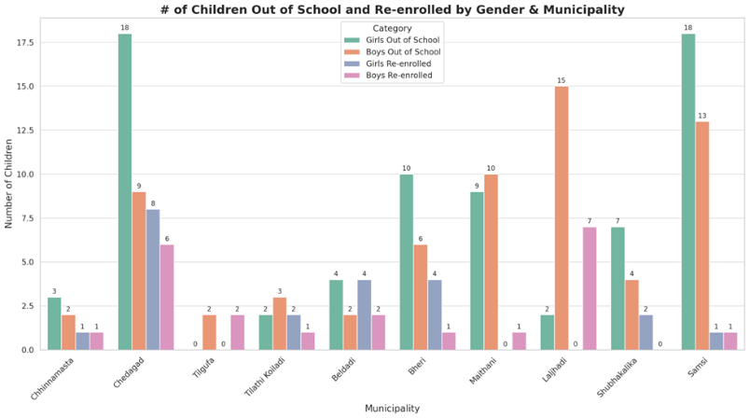
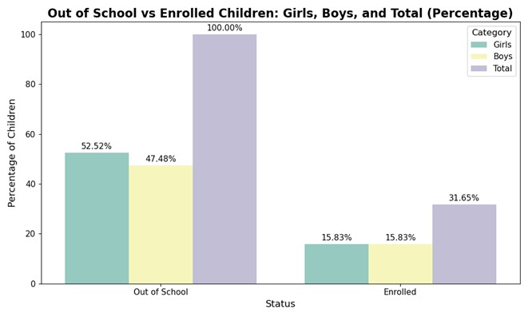
The project identified 139 out-of-school children (Girls: 73, Boys: 66, including Madhesi: 22, Brahaman/Chhetri: 21, Tharu: 21, Dalit: 41, Muslim: 26, Janajati: 8, and children with disability:73). Among the key reasons for being out of school, ‘physical disability’ was the most significant, accounting for 43.88% of the 139 children who are identified as out of school. ‘Poverty’ was another major barrier, affecting 41.01% of children, lack of child-friendly teaching environments affecting 10.07%, while the ‘remoteness of schools’ contributed to 7.91%. Other reasons include one child not being interested in study , difficulty understanding the school curriculum due to language barriers 1.44%, and other reasons like child marriage, child labor, parentless children etc affecting 8.63% of the total. These findings highlight the urgent need for targeted interventions to address these barriers and support inclusive education access. Out of the 139 identified children, the project facilitated with the enrolment of 44 (including 22 girls) children in school through the School-at-Home program and school enrolment campaign. Further, consultation workshops and policy gap analyses with municipal governments have laid the groundwork for revising and developing inclusive education policies and plans. Community-level discussions, such as parent-peer support groups and Chhalphal Chautari, have raised awareness about inclusive education provisions and gaps in implementation. For example, discussions were held regarding how the government has a provision that new school buildings must have ramps so that children with physical disabilities can access to classroom easily. However, in reality, many schools do not build these ramps. They also talked about problems faced by girls. Even though schools are supposed to be girl-friendly, many of them still don’t have a proper way to dispose of used sanitary pads. This makes it hard for girls to attend school during their periods. These forums have empowered parents and community members to voice their concerns and advocate for effective implementation of inclusive education policies. They are now actively raising their concerns and pushing local authorities to make schools safer, more supportive, and protective for all children. Children have also been actively involved through Baal Kachahari (child led round table discussion) programs, where they raise issues related to barriers faced by girls, Dalits, and children with disabilities in accessing education, the impact of child and early marriage on education, the rise of drug use among teenagers, and the need for a friendly school environment to ensure equitable access to quality education in the presence of local government and concerned stakeholders.
CSOs have been working as the bridge between the community and local government to share issues and hold the government accountable for implementing inclusive policies. The formation, reformation, and activation of inclusion-related structures like Disability Coordination Committees (DCCs), Girls Inclusive Education Networks (GIENs), and Personal Assistance Service Referral Committees (PASRCs) have further strengthened their capacity on governance and accountability. The capacity of CSOs was strengthened through targeted training and workshops. A four-day training was conducted based on a capacity assessment of each CSO. The training content was tailored to address the specific needs identified in these assessments. Key topics included advocacy for inclusive policies and their implementation, disability rights, gender equity and social inclusion (GESI), leadership development, resource mobilization and utilization, as well as the FSTP process and its objectives.
In addition, a capacity-building workshop was held to strengthen understanding of financial processes and procedures. Regular meetings were also conducted to support CSO capacity assessments, the development of organizational capacity development plans, and to strengthen linkages with inclusion-related structures such as GIEN, DCC, parent peer support groups, and Palikas.
These structures have developed annual action plans to ensure the effective implementation of inclusive education policies and provisions, making the government and concerned authorities accountable.
Overall Objective – Impact level Indicator | Baseline Y1 | Target value  Y4 | Current value  Y 1
Number of government policies/strategies/plans developed or revised with civil society organisation participation through EU support* (with a focus on equity and inclusion) | 0 | 10 | 0
Although no government policies have been developed or revised with CSO participation through EU support so far, the project’s ongoing efforts and established processes indicate a strong likelihood of achieving the project's targets by 2027 as planned. The project's comprehensive approach, including capacity building, community engagement, and policy advocacy, is effectively driving progress towards its overall objective of fostering equitable and inclusive educational outcomes in the project's working areas.
Challenges:
The project has formed, reformed, and activated over 207 committees, groups, and networks at the community level. These entities expect both technical and financial support from the project to implement their annual plans. However, the project faces significant resource constraints, particularly in terms of technical personnel and financial support. For instance, a single Education Officer is responsible for two Palikas in hilly areas where settlements are scattered, resulting in more travel time than working time. Despite these challenges, we are making concerted efforts to address these issues by coordinating with other projects funded by SC and coordinating with Palika for financial support.
Additionally, out of 139 children identified as out of school, 73 have been identified as children with disabilities, including 21 with multiple disabilities. Enrolling children with multiple disabilities in either school or home-based programs is particularly challenging. Our target is to achieve an 80% enrolment rate for the 139 out-of-school children. We continue our efforts to enrol these children in resource schools or home-based programs, considering the severity of their disabilities.

Furthermore, parents from very poor families prioritize food over education, making it difficult to enrol and retain their children in school. To address this, the project has coordinated with the Palika and other organizations to support these families' livelihoods.
The project has made its best efforts to address cross-cutting issues throughout its implementation. Based on the project's scope, below are the key highlights of these cross-cutting efforts:
Promotion of Human Rights: The project integrated human rights principles by ensuring inclusive participation, equitable access to education, and advocacy for marginalized communities. Special focus has been placed on girls, Dalit children and persons with disabilities, indigenous groups, Madheshi and other vulnerable populations to promote their rights and opportunities in education and governance.
Gender Equality: The project actively promoted gender equality by ensuring inclusive participation of women, girls, Dalit, Janajati, marginalized families and person with disabilities in community structures such as parents' peer support groups, child clubs, the Girls’ Inclusive Education Network (GIEN), disability coordination committees, and ward-level personal assistance service referral committees as per the nature of the structure. Equal opportunities were provided, which is guided by the quality benchmark of the project in all trainings, meetings, orientations, and workshops, ensuring marginalized and vulnerable groups has access to project benefits. Additionally, all the PNGOs (NNSWA, RDRC, and StS) were assessed on Gender Equality, Disability, and Social Inclusion (GEDSI), and based on the findings, five days ‘Co-applicants capacity development’ training on Gender Equality, Disability and Social Inclusion was provided to executive board members and project staff. This helped them begin integrating GEDSI principles into their organizational policies and plans. In all the project documents and activities, gender equality, disability inclusion, social inclusion, and an intersectional lens have been ensured.
Democracy: Democratic principles were upheld throughout project implementation, particularly in the formation of local structures, project beneficiary selection and stakeholder engagement. The project encouraged the active participation of all beneficiaries, ensuring diverse voices—including those from different age, sex, gender and sexuality, castes, disabilities, ethnicities, marginalised and religions—were heard and respected. Feedback from stakeholders was incorporated into project activities where feasible.
Good Governance: A robust Monitoring, Evaluation, Accountability, and Learning (MEAL) system has been implemented to promote transparency and accountability. Project objectives, budgets, and participant roles are communicated at the start of all meetings, trainings, and orientations. A toll-free feedback mechanism has been shared with the participants to submit complaints, feedback, or appreciation, maintaining confidentiality. The project also ensured accountability by defining clear roles and responsibilities within various established structures. Zero-tolerance policies are strictly enforced, including the SCI Safeguarding Policy, Anti-Harassment Policy, Protection from Sexual Exploitation and Abuse (PSEA) Policy, Fraud, Bribery and Corruption Policy, and Human Trafficking and Modern Slavery Policy.
Children’s Rights: As a child rights-focused organization, Save the Children ensured that all project activities are aligned with the promotion and protection of children's rights. The project contributed to equitable access to quality education, supporting children unable to attend school physically through the School-at-Home program. Scholarships were provided in coordination with Palikas to marginalized children to continue their education. During the flood response in Kanchanpur, children received non-food item kits to support their well-being. Child safeguarding and rights were integrated into all project activities, with staff, vendors, suppliers, and consultants signing and adhering to child safeguarding policies.
Indigenous Peoples: The project worked with Magar and Tharu indigenous communities in the implementation areas, ensuring children from these groups are not left behind in education due to language barriers. Additionally, committees/agencies such as the Aadibasi Janajati Sangh and Laljhadi led by representatives from the indigenous communities have been engaged in the project, further fostering inclusive development and leadership.
Youth: The project actively engaged Youth Sounding Board (YSB) members, organizing monitoring visits across provinces and including them in the annual project review meeting. YSB members also participated in children and youth leadership development programs and advocacy training to strengthen their engagement in policy dialogues. Their critical feedback and suggestions have contributed to improving project implementation.
Environmental Sustainability: Environmental sustainability has been integrated into project operations through various eco-friendly practices: Eliminating the use of plastic bottles in office premises and events, avoiding flex banners where possible and opting for electronic banners instead, encouraging the use of public transportation by participants and organizers, incorporating environmental sustainability criteria in consultant assessments scoring template, use of online survey and monitoring using like KOBO tool instead of using paper, and "Green School" campaigns to promote environmental awareness in education settings are some of the actions taken by the project to foster environmental sustainability.
HIV/AIDS: While HIV/AIDS is not a primary focus of the project, awareness-raising activities and inclusive approaches ensured that individuals affected by HIV/AIDS were not discriminated against.

Specific Objective – “To strengthen civil society’s role in promoting inclusive access to quality education for all”
The project has taken important steps in strengthening grassroot civil society organizations (CSOs) in promoting inclusive access to quality education for all. A total of ten CSOs have been selected in coordination with the Local Governments, with one CSO in each Palika (including two Organizations of Persons with Disabilities (OPDs), three youth-led organizations, and five women-led organizations). In each project municipality, a CSO has been engaged in promoting equity and inclusion in education. Following their selection, CSO members underwent a four-day training course covering topics related to advocacy, leadership, social inclusion, inclusive education and financial management. Additionally, they received an orientation on their expected roles and responsibilities within the project, ensuring clarity on partnership with project and engagement strategies.
In addition to these efforts, although the formal development of role models is scheduled for Year 2, progress has already begun. Two OPDs supported by the project have actively engaged in community awareness and advocacy activities. Within the ten CSOs, two persons with disabilities who participated in capacity development training are informally serving as role models, contributing to positive change for persons and children with disabilities. Furthermore, a facilitator with a disability under the school-at-home program and two youth volunteers with disabilities, along with 33 young female volunteers, are inspiring children and promoting inclusive and girls’ education in their communities.

To enhance their influence, CSOs have been linked with key inclusion-related local structures, including Girls Inclusive Education Networks (GIENs), Disability Coordination Committees (DCCs), Personal Assistance Support Service Committees, parents' peer support groups, schools, and child clubs. This coordination has enabled CSOs to develop annual action plans for 2025, incorporating key community concerns to promote inclusive education such as enrolling out-of-school children, facilitate to create inclusive school environments—particularly for girls and children with disabilities—supporting local governments in drafting inclusive education policies and plans, raising awareness about the importance of education and disabilities, gender equality and social inclusion, promoting the rights of children with disabilities and girls, and advocate for more budget allocations for inclusive education.

These action plans have been submitted to local governments for financial support, and municipalities have committed to integrate them into their upcoming fiscal budgets. Additionally, CSOs, in collaboration with trained youth volunteers, are conducting awareness campaigns on equity, inclusion, and quality education at community level. In addition, two persons with disabilities from supported CSOs, a facilitator with a disability under the school-at-home program, and 33 young female volunteers are informally serving as role models. Their engagement is inspiring children with disabilities and promoting inclusive and girls’ education within their communities.

SN | Indicator | Baseline Y1 | Target value Y4 | Current value Y1
1 | % increase in knowledge of target CSO representatives on equity and inclusion in education policy implementation compared to baseline (disaggregated by sex, disability, and ethnicity) | 0 | 30% | 0  This is planned to be assessed in Y3
2 | % of identified out-of-school children (age 5-12) in catchment area who are enrolled in Basic Education (disaggregated by sex, age, ethnicity, disability) | 139 out of school children  (Girls: 73, Boys: 66 and children with disabilities: 73; Ethnicity-wise: 21 Brahmin/Chhetri, 41 Dalit, 26 Janajati, 26 Muslim, 22 Terai Madheshi, and 3 others.) | 111 of 139  80% | 44 out of 139 enrolled in school  (31.6.%)  (Girls: 22, Boys: 22 and children with disabilities: 26, Ethnicitywise Brahman/Chhetri :8, Dalit: 18, Janajati: 13, Muslim: 3, Other, Terai and Madhesi: 2,)
The above baseline data indicate a significant knowledge gap among CSO representatives on equity and inclusion in education policy implementation. To address this, the project is planning further training, exposure visits, and orientations to strengthen their capacity. An endline assessment in 2027 will measure progress. Likewise, the project identified 139 out-of-school children aged 5-12, of whom 44 have been enrolled in school (It includes the enrolment of 30 out-of-school children in school at home program and 14 out-of-school children in regular schools) through the School-at-Home program and school enrolment campaign. Additional efforts to enrol out-of-school children will be made during the 2025 academic year, starting in May 2025, as the previous academic year had already begun, and the enrolment campaign was closed. As the project has limited resources to include additional children in the School-at-Home program, the project team is coordinating further with local governments to support with conducting the School-at-Home program for additional children in the project's working areas.
Output 1: Opportunity costs and social-norm-driven barriers to accessing education are reduced through locally led solutions
Till the reporting period, implemented activities have made notable progress by addressing key barriers: these include harmful beliefs such as: children with disabilities cannot learn and therefore shouldn't be sent to school; girls, especially after marriage, no longer need education as they are expected to care for their families; and children from poor or marginalized families are better off working—helping their parents in jobs like tailoring or doing household chores for wealthier families. Through targeted activities, the project is conducting awareness raising activities and creating more inclusive opportunities for girls, Dalits, children with disabilities, and others from disadvantaged communities. Through a combination of community-led awareness initiatives, disability screening and referrals, school-at-home programs, and parent-peer support groups, the project is fostering an inclusive and supportive educational environment.
One of the most impactful interventions has been the mobilization of community youth volunteers, who have been trained to lead structured awareness sessions on disability rights, social inclusion, and government support mechanisms. These efforts have empowered communities to challenge deep-rooted social norms that hinder access to education to some extent, particularly for girls, Dalits, and children with disabilities. Among the facilitators trained under the school-at-home program, one facilitator and two youth volunteers who are persons with disabilities have taken leadership roles in conducting sessions. By sharing their personal experiences and commitment to education, they are inspiring children with disabilities to enrol and continue their education, while also raising community awareness on overcoming barriers to learning through real-life examples.
Additionally, the strong collaboration with local governments, OPDs, and CSOs has raised the issues of inclusion that need to be integrated into local policies and sustained beyond the project's duration. The formation and mobilization of Disability Coordination Committees (DCCs), Girls Inclusive Education Network (GIEN) and Personal Assistance Service Referral Committees (PASRCs) have further strengthened governance structures to support the educational needs of marginalized children.
The disability screening camps, assessment of children's functional limitation using the Washington Group of Questionnaire (WGQs) and reporting children with disability data in a sub-tab of Integrated Education Management Information System (IEMIS), have significantly enhanced the identification and support of children with disabilities in schools. The trained education officers and teachers are now equipped to assess and accommodate children with diverse needs, ensuring that they receive scholarships, assistive devices, and inclusive learning support
For children who couldn’t attend school physically, the school-at-home program has provided an innovative solution to bridge the accessibility gap. This initiative has not only facilitated home-based education but has also engaged therapists and teachers to support children's physical and cognitive development, significantly improving their learning outcomes and quality of life. Parents of children benefiting from the program have reported remarkable improvements in their children's mobility, confidence, and emotional well-being, reflecting the broader impact of inclusive education efforts.
One such inspiring story is that of Siramato, a parent of a school-at-home child. She shared her emotional journey:
"This is my only child. Earlier, my child could not even stand, and I had lost all hope. I was so disheartened that I stopped caring for myself—I never used cosmetics like lipstick, kajal, or powder, and I didn’t even manage my hair. But after seeing my child’s progress, everything has changed. I have started using lipstick, kajal, powder, and taking care of myself again. My happiness is limitless. I feel so lucky to have connected through NNSWA with this project and to have received such support at home. Now, I dream of seeing my child enrolled in school next year, studying with other friends."
The formation of parent-peer support groups has been instrumental in strengthening community engagement. These groups have created safe spaces where parents, particularly from marginalized backgrounds, discuss educational barriers, access government provisions, and advocate for their children's rights. By fostering collective action and accountability, these groups are playing a vital role in shifting community attitudes toward education and promoting equity and inclusion.
SN | Indicator | Baseline Y1 | Target value Y4 | Current valueY1)
1 | Number of teachers, members of SMC, PTA and parents oriented/trained on equity and inclusion in education (disaggregated by sex, disability) | 0 | 2150 | 0  This is planned for Y2
2 | Number of model schools for equity and inclusion in education established | 0 | 30 (2026) | 30 schools have been selected, but their establishment as model schools is in progress.
3 | Number of palikas/cooperatives that establish funding mechanisms to support vulnerable and out of school children | 0 | 10 (2026) | 0  This is planned for Y2
Under Output 1, three key indicators are planned for achievement in Year 2. However, initial steps have already been taken to ensure steady progress. The selection of 30 model schools has been completed under the leadership of the Palika. Preparations for capacity-building activities are also underway. In Year 2, teachers, School Management Committee (SMC) members, Parent-Teacher Association (PTA) representatives, and parents will receive training and orientation on equity and inclusion in education. Simultaneously, the development of model school indicators has begun, and consultations with Palikas are in progress to establish funding mechanisms that will support vulnerable and out-of-school children.
The project has made good progress in reducing opportunity costs and addressing social-norm-driven barriers to education by empowering communities, strengthening institutional mechanisms, and enhancing service delivery. These locally led solutions are ensuring that the most disadvantaged children, including girls, Dalits, and children with disabilities, have equitable access to education, support services, and opportunities for a better future. Moving forward, the continued collaboration with government entities, local organizations, and communities will be essential in ensuring the sustainability and scalability of these interventions.
Output 2: Civil society and youth’s capacity to drive equity and inclusion in education is increased
To strengthen civil society and youth to drive equity and inclusion in education, the project progress is moving forward by enhancing organizational capacity, advocacy and leadership skills, and mobilizing resources for inclusion and inclusive education initiatives. The project carried out Organizational Capacity Assessments (OCA) of partner organizations, leading to tailored capacity development plans. In August 2024, a five-day training equipped PNGO executive board members and staff with skills in inclusion, inclusive education, advocacy, and governance.
Additionally, 10 grassroots CSOs, including women, youth, and disability-led organizations, are selected under the Financial Support to Third Parties (FSTP) program. These organizations received training in advocacy, leadership, and resource mobilization to strengthen their role in promoting inclusion and inclusive education policies. These CSOs have actively engaged with local governments and communities, with one in Laljhadi successfully securing NPR 250,000 (equivalent to EUR 1,604). The grant was provided to support CSOs for conducting community-level activities based on their action plan, developed with technical support from the project, to promote inclusive education. This includes enrolling out-of-school children, creating inclusive school environments for girls and children with disabilities, and supporting the development of inclusive education policies. Additionally, the grant helps raise awareness about education, disabilities, gender equality, and social inclusion. Other CSOs have submitted proposals to integrate equity and inclusion initiatives into municipal budgets, reinforcing sustainability and local ownership.
Weekly virtual meetings and mentoring plans, led by Save the Children and Resource Centre for Rehabilitation and Development (RCRD) have further enhanced collaboration, knowledge-sharing, and technical clarity among partners. Youth Sounding Board members are engaged in project monitoring across all implementing provinces, participating in project review meetings, and attending various trainings such as leadership and advocacy skill development. They have provided valuable inputs in different platforms for the project's improvement.
SN | Indicator | Baseline Y1 | Target value Y4 | Current value (Year 1)
1 | Number of youth-led research pieces on equity and inclusion in education produced | 0 | 4 | 0  This is planned for Y3
2 | Number of grassroots civil society organisations benefitting from (or reached by) EU support | 0 | 10 | 10 10 CSOs have been selected and supported on capacity strengthening in leadership, advocacy, financial management, and the FSTP process in Year 1, However, FSTP support is planned for Year 2.
Under Output 2, there are two indicators planned: one is youth-led research on equity and inclusion in education, which is planned for Year 3, and continued support to grassroots CSOs through the FSTP program in Year 2. By systematically equipping local CSOs with the necessary skills, resources, and platforms for advocacy, the project is ensuring sustained momentum in advancing equity and inclusion in education.
Output 3: Coordination between civil society and the three levels of Government in the education sector is enhanced
Till the reporting period, the project has made good progress in fostering coordination between civil society and government to advance inclusive education. By formation/reformation and activation of 107 local-level equity and inclusion structures, including 10 Disability Coordination Committees (DCCs), 87 Personal Assistance Service Referral Committees (PASRCs), and 10 Girls and Inclusive Education Networks (GIENs), the project has ensured structured engagement on equity and inclusion. These groups have started advocating for inclusive education policies, and plan integrating their action plans into municipal budgets, and actively participating in local level planning process and ten years education planning of Palika.
At the policy level, 10 diverse CSOs have been engaged in federal, provincial, and local education policy dialogues, raising their voices in shaping education policies, strategies and plans. The project’s advocacy efforts, joint monitoring visits, and engagement in education policy dialogues have strengthened multi-stakeholder collaboration, making education more inclusive and responsive to the needs of girls, Dalits, children with disabilities and marginalized children. By institutionalizing these mechanisms, the project is contributing to long-term policy alignment and sustainability.
SN | Indicator | Baseline Y1 | Target value Y4 | Current value (Year 1)
1 | Number of local level equity and inclusion structures formed/reformed and activated | 11 | 107 | 107
1 | - Disability Coordination Committee | 10 | 10 | 10
1 | - Personal Assistance Service Referral Committees | 0 | 87 | 87
 | - Girls and Inclusive Education Network | 1 | 10 | 10
2 | Number and diversity of CSOs invited/participating in/contributing to national, provincial, and local/sectoral development plan/strategy policy discussions or consultations on draft laws/policies | 0 | 10 | 10
Under Output 3, all indicators are related to the formation, reformation, and activation of local-level equity and inclusion structures. These structures have been established and are actively functioning in accordance with their roles and are coordinating effectively with the government at all levels.
At the local level, the project has significantly enhanced coordination between civil society organizations (CSOs) and local governments (Palikas). Tripartite agreements have been established, clearly defining roles and responsibilities, which has facilitated resource-sharing and policy alignment. This collaboration will lead to the development of inclusive resource hubs, teacher training, strengthening of CSOs, disability screening camps, and the implementation of the School-at-Home program. The active involvement of state authorities has improved credibility and access to resources for marginalized groups. Local governments are committed to scaling up successful initiatives and incorporating best practices into their policies, ensuring long-term sustainability and a more inclusive education system.
At the provincial level, the project closely coordinated with the Ministry of Social Development (MoSD), particularly the Education Development Division and the Education Development Directorate. This ensured active government participation in key project activities such as kick-off meetings, reviews, and sharing sessions. The project also provided technical input in developing provincial education plans, contributing to the drafting of education plans for Karnali and Madhesh provinces.
At the national level, the project worked closely with the CEHRD. This included the joint development of a Universal Design for Learning (UDL) flip book and the rollout of IEMIS training, focusing on the disability sub-tab. Additionally, the project coordinated with the Ministry of Women, Children, and Senior Citizens to institutionalize the Disability Management Information System (DMIS) and provided technical input on the education act of Nepal, which is currently under discussion in the cabinet. These efforts were supported both at the project level and by Save the Children as an organization.

B. ACTIVITIES
Output 1:
A.1.1 Community-led disability awareness and action planning
A guideline for the selection of community youth volunteers has been developed in collaboration with local Organizations of Persons with Disabilities (OPDs), Civil Society Organizations (CSOs), in consultation with local governments. Based on this guideline, local governments published vacancies and facilitated an inclusive recruitment process between September and October 2024 in all the project working palikas, resulting in the selection of 50 youth volunteers (33 females, 17 males, including Madhesi: 15, Brahman/Chhetri: 21, Tharu: 6, Dalit: 5, Janajati: 3, and 2 persons with disabilities). The selected volunteers received three days ‘Capacity building training to youth community volunteers. The training in Madhesh Province was held first, from 18 to 20 September 2024. After that, the training for youth volunteers from Karnali and Sudurpaschim provinces was organized in Surkhet from 19 to 21 September 2024. The volunteers are now actively leading community-led awareness-raising sessions focused on inclusion, disability rights, and social protection services (SPS). Notably, Bheri Municipality, Chhedagad Municipality, and Laljhadi Rural Municipality have expressed their commitment to sustaining these volunteers beyond the project's duration, demonstrating their dedication to promoting long-term inclusion and support for marginalized groups.
Bishnu Maya Shrestha Rana, a community youth volunteer, said "When I was selected as a community youth volunteer, I felt both happy and anxious because I had no experience in training and facilitating meetings. During the three-day training, I learned a lot about community mobilization, disability, inclusive education, and facilitation skills. At the end of the training, we made a plan to conduct community awareness sessions. In my first session back home, I found it difficult to facilitate in front of familiar faces, but our education officer from NNSWA helped me. By the second session, I started to overcome my shyness and build confidence. Many people appreciated my sessions, which boosted my confidence even more. Now, I actively share my thoughts and ideas in meetings at the Palika and community levels. This training has changed me in many ways. I learned how to interact with people with disabilities and children, respect others' opinions, and much more. I feel very lucky to have this opportunity and want to thank the EU, Save the Children, and NNSWA. Even though we are working as volunteers, I am very happy to learn and work for our communities."
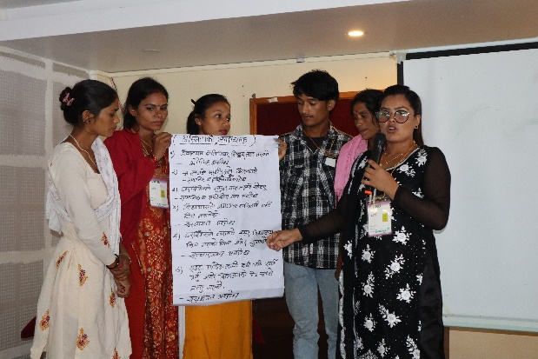
In September 2024, the project conducted a three-day training on social inclusion, disability and community mobilization in Madhesh and Karnali provinces for 50 community youth volunteers (Male: 17, Female: 33). A guideline was developed for the selection process, which emphasized giving priority to females, Dalits, Janajatis, and individuals from marginalized communities. As a result, the project successfully ensured the participation of 30 female youth community volunteers. The training in Madhesh Province was held first, from 18 to 20 September 2024. After that, the training for youth volunteers from Karnali and Sudurpaschim provinces was organized in Surkhet from 19 to 21 September 2024. The training equipped these volunteers with the skills to facilitate structured awareness-raising sessions based on an eight-session guideline developed by the project team. Since December 2024, 234 such sessions have been conducted on a fortnightly basis, each resulting in actionable plans. These sessions have played a crucial role in raising awareness on government policies on equity and inclusion, disability rights, children´s rights and key issues such as, barriers faced by marginalized girls, Dalits, children with disabilities, and children from disadvantaged families in accessing education, and how to utilize available support services. As a result, participants are becoming more aware of the rights of persons with disabilities, girls, Dalit and disadvantaged groups, social inclusion principles, and government support mechanisms, empowering them to take informed steps toward utilizing these services effectively. Additionally, local CSOs have integrated issues raised during these sessions into their organizational plans and shared them with local governments. Critical concerns such as persons with disabilities still lacking disability identity cards, ineffective implementation of the mid-day meal program, lack of girls friendly WASH facilities in school and hidden costs in so-called "free" education—etc. have been raised in community discussions through Chhalphal Chautari (parents' discussion forums). These dialogues are helping increase accountability among service providers and bringing attention to the pressing needs of marginalized communities.

"At the community level, awareness programs are being conducted in various localities to raise awareness about the rights of persons with disabilities, girls, Dalit, and disadvantaged children. These efforts are very impressive, as parents are receiving information about disability cards, scholarships for girls, Dalit, and Janajati children, and how to access these scholarships and government services. They are also learning about the use of respectful language when communicating with persons or children with disabilities. I am pleased with these efforts and would like to express my gratitude to the project. I also wish for the continued success of such initiatives in the future," said Baldev Mandal, President of the Disability Association, Saptari.

- A one-day orientation was conducted between August and September 2024 for Disability Coordination Committee (DCC) members, Palika representatives, and CSOs on disability, social inclusion, with a total of 250 participants (Female: 73, Male: 175, Girls: 0, Boys: 2, Madhesi: 73, Brahman/Chhetri: 112, Tharu: 14, Dalit: 28, Muslim: 5, Janajati: 18, and Persons with Disabilities: 16). This is a Palika-level event, so it was conducted on different dates across various locations. This orientation strengthened collaboration among stakeholders, resulting in active support for community youth volunteer-led activities and fostering a more coordinated approach to promoting disability rights, girls education, inclusive school environment and participation of women, Dalit, Janajati and backward communities in decision making process. Additionally, 2,740 community members (Female: 1,410, Male: 1313, Girls: 11, Boys: 6, Madhesi: 670, Brahman/Chhetri: 387, Tharu: 62, Dalit: 951, Muslim: 478, Janajati: 192, and Persons with Disabilities: 295) from parent-peer support groups and ward-level Personal Assistance Service Referral Committees benefited from ward level awareness raising initiatives on disability and social inclusion. These efforts have significantly contributed to raising awareness about disability rights, available services, and inclusion, ensuring that diverse community groups are engaged in the movement toward equitable access and support.
A.1.2 Promote disability screening campaigns at ward level and referrals to relevant health & social protection services
The project collaborated with all three tiers of government and stakeholders to enhance access to education and promote an inclusive learning environment for children with disabilities, girls, Dalits, and children from marginalized communities. In partnership with the Ministry of Education, Science, and Technology (MoEST) and the Center for Education and Human Resource Development (CEHRD), the project addressed gaps in implementing the disability sub-tab in the Integrated Education Management Information System (IEMIS). The Ministry of Education, Science and Technology (MoEST) has developed the Integrated Education Management Information System (IEMIS), which includes a sub-tab for reporting data on students with disabilities. Previously, disability-related information was underreported due to teachers' limited knowledge and skills in data entry. To address this, the project provided orientation to Palika-level education officers and schoolteachers responsible for entering data into IEMIS. Following these orientations, schools have begun to report disability-related data more accurately through the IEMIS platform. To build technical capacity, Education Officers from all the project working Palikas were trained on the disability sub-system in IEMIS, and these officers, in turn, oriented school IEMIS focal teachers across all Palikas during August and September 2024 on disability reporting and screening using the Washington Group Questionnaire for Child Functioning Module of government (WGQs-CFM) tool. A total of 208 teachers participated in these orientations (Female: 33, Male: 175, Madhesi: 57, Brahman/Chhetri: 102, Tharu: 21, Dalit: 20, Muslim: 4, Janajati: 4, and Persons with Disabilities: 3).

Following the orientations on IEMIS and WGQs-CFM, schools have begun reporting data on children with disabilities, ensuring these students can access essential government support such as scholarships, assistive devices, and midday meals. Teachers have also started incorporating inclusive practices in their classrooms based on the findings of children's functional assessment, such as improving seating arrangements to accommodate children with low vision or hearing difficulties and integrating inclusive strategies into School Improvement Plans (SIPs). These efforts are creating a supportive learning environment for all students and laying the foundation for sustainable, long-term inclusive practices in schools.

Dipendra Bahadur Budha, a teacher from Beldandi shared, "I used to focus only on students' learning outcomes, without considering why some children were struggling. I assumed the problem was their home environment, poverty, or lack of discipline. But after I participated in the child functional limitation assessment using the Washington Group Questionnaire, I realized many children face learning difficulties due to hearing problems, poor vision, memory challenges, or lack of individual support. This changed my perspective. Now, I identify children's functional limitations in class and provide support based on their needs. Sometimes, I also refer them for further treatment. This tool has been incredibly helpful in creating an inclusive classroom environment."

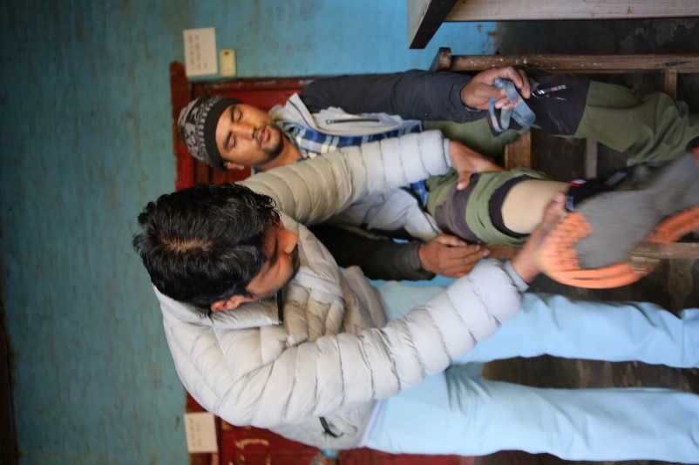
Between November 2024 and February 2025, in collaboration with Palikas, ward personnel, schools, and health institutions, the project organized 17 community and school-based disability screening camps. The active participation of Palika representatives, medical doctors, technical teams from physical rehabilitation centers, Disability Coordination Committees (DCC), Organizations of Persons with Disabilities (OPDs), and schools was crucial in making these screening camps successful. In total, 1,424 individuals were screened, identifying 1,026 persons, including 511 children, with disabilities. Following the screenings, recommendations were made for assistive devices, with 43 individuals already receiving these devices. Some of the assistive devices given are wheelchair, white cane, hearing aids, eyeglasses, Ankle-Foot Orthoses (AFO) brace, clubfoot brace, prosthetic hand, walking sticks, etc. Furthermore, 19 disability identity cards, including 10 for children, were issued, enabling easier access to government services and support mechanisms. This initiative has significantly improved the visibility of children with disabilities in schools and communities, enhancing their access to education and essential resources. These efforts mark an important step toward creating a more inclusive and supportive environment for persons with disabilities, embedding them more fully into education systems and community life.

"We did not have knowledge about disability screening camps and the technical organizations that support these camps. Previously, we were only focused on disability ID cards distribution. This time, we had the opportunity to collaborate with an EU-funded project and organized a screening camp where persons with disabilities visited, received assistive devices, and recommendations for further treatment. Some of them also received ID cards. We are thankful to this organization and will try our best to organize such disability screening camps in the coming years," said Chief Hari Prasad Mandal, Matihani Municipality.

Between November 2024 and February 2025, the project facilitated the formation, reformation, and activation of all ten Disability Coordination Committees (DCCs) and the formation of 87 Ward level Personal Assistance Service Referral Committees (PASRCs). The DCCs and WPASRCs are formed and reformed in collaboration with local governments, ensuring representation of diverse groups based on the guideline. Orientation sessions were conducted for members of both committees, focusing on disability rights, constitutional provisions, relevant laws and acts of Nepal, and the specific roles and responsibilities of DCC and ward PASRC members. As a result of these meetings, both committees developed detailed action plans aimed at conducting awareness-raising campaigns on disability, coordinating with Palikas and other stakeholders for disability screening camps, creating inclusive learning environments in schools, expanding the School-at-Home program, facilitating the issuance of disability ID cards, and holding meetings with local governments to promote inclusive budgeting and its implementation.

Additionally, orientation was provided to DCC members on the Disability Management Information System (DMIS). However, the system is not yet operational due to technical challenges, including data security concerns and hosting issues, as the system is currently managed by an external consultant which was developed with the support from Unicef and Save the Children. The project team is coordinating with the Ministry of Women, Children and Senior Citizen to transfer ownership of the DMIS tool to the government and scale its implementation nationwide, ensuring secure and effective disability data management.

A.1.3 Expand revenue streams (public/private) in the form of need-based scholarship and bursary support for children
To identify out-of-school children aged 5–12 years, a census survey was conducted from July to December 2024. The survey identified 139 out-of-school children (Girls: 73, Boys: 66, Madhesi: 22, Brahaman/Chhetri: 21, Tharu: 21, Dalit: 41, Muslim: 26, Janajati: 8, and children with disability:73). To support children with disabilities who cannot attend school physically, the project introduced a school-at-home program. 44 children are enrolled from the different initiatives of the project: A total of 30 children with disabilities have been enrolled in this initiative and additional 14 children are enrolled in school through enrolment campaign. These children are enrolled in the nearest schools, where they receive the same benefits as other students, including scholarships, midday meals, and textbooks. Additionally, school teachers visit the children from the school-at-home program to monitor the children’s learning progress and provide technical support to the program's teachers, ensuring improved educational outcomes.
As part of the school-at-home program, trained teachers visit children’s homes daily to support their learning and development in a familiar environment. The program runs for at least four hours each day, from Sunday to Friday, except on government holidays.
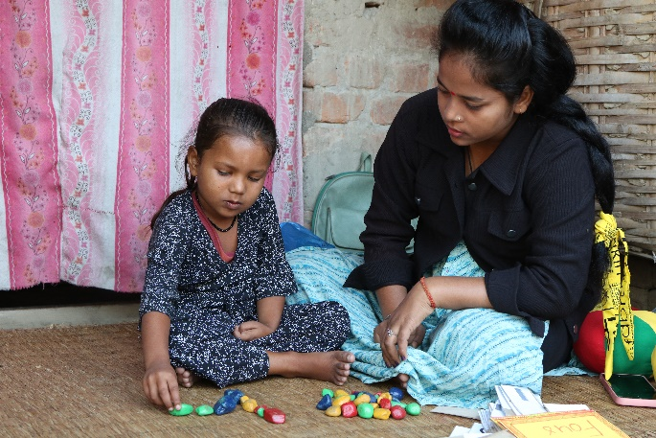
The project is also coordinating and engaging physiotherapists as needed, who visit the children’s homes to guide teachers and parents on conducting daily physiotherapy exercises. As a result, significant improvements have been observed in children's physical abilities who are struggling with physical challenges. Some children who were previously unable to stand or walk have now started standing and walking slowly, showing remarkable progress. Additionally, their psychological well-being has improved due to regular interactions with teachers and external visitors. This engagement has not only benefited the children but has also brought hope and happiness to their parents.
"School at home is a very effective approach to ensure access to education for children with disabilities who cannot attend school physically. We are collaborating with this EU-funded project and have enrolled these children in school too, and providing them with support such as scholarships, mid-day meals, stationery and textbooks. We are very thankful to the EU and Save the Children for introducing this new initiative in our Palika. We will continue this effort even after the project phase-out and will support other children who are not covered by the project," said Siddha Raj Bhatt, Education Officer of Laljhadi RM.
To effectively implement the school-at-home initiative, 30 facilitators (Female: 23, Male: 7, Madhesi: 8, Brahmin/Chhteri: 10, Tharu: 4, Dalit: 4, Muslim: 1, Janajati: 3, and person with disability: 1) were selected and trained in collaboration with the Palikas. The facilitators participated in a five-day training held between August and October 2024. There were two trainings conducted: one in Madhesh Province from 20th to 24th October 2024 in Lahan, and another in Surkhet from 25th to 29th July 2024 for participants from Karnali and Sudurpaschim Provinces. The training covered topics such as disability types, tailored pedagogical strategies, individual education plan (IEP) development, learning materials development, and safeguarding practices when working with children. Following this comprehensive training, the facilitators are now effectively conducting the school-at-home program, ensuring that children receive quality education in an inclusive and supportive environment.
In addition, 44 out-of-school children (Girls: 22, Boys: 22, Madhesi: 4, Brahmin/Chhetri: 8, Tharu: 9, Dalit: 16, Janajati: 3, Muslim: 4 Children with disability: 27 ), and at risk of school drop-out children were supported with educational materials like stationery, uniforms, and assistive devices to help them continue their education. These efforts have not only improved access to education for children with disabilities but have also contributed to creating a more inclusive learning environment that addresses the diverse needs of all students.
Through these initiatives, the project is making significant progress in ensuring education for children with disabilities and marginalized groups. By linking children to schools, training facilitators, and providing essential support, the initiative is building a more inclusive and equitable education system, where every child has the opportunity to learn and grow.
The activity related to expanding revenue streams (public/private) in the form of need-based scholarship and bursary support for children is planned for Year 2.
A.1.4 Training for model schoolteachers/SMC/PTA members on equity and inclusion in education for upgrading SIPs
Not applicable as this activity is planned for Year 2
A.1.5 Orientation of non-model school SMC/PTA members on equity and inclusion in education
Not applicable as this activity is planned for Year 2
A.1.6 Establish parent peer-support groups
In all 87 wards of the project area, the project has formed 87 parents-peer support groups from July to November 2024, consisting of a total of 2,228 parents from marginalized groups, including Dalits, Janajatis, and parents of children with disabilities, following the Chhalphal Chautari guideline. The groups are diverse, with 1,347 female and 881 male members, including representation from Madhesi (318), Brahman/Chhetri (691), Tharu (140), Dalit (731), Muslim (172), Janajati (176), and 282 persons with disabilities. During the formation of these groups, all members received orientation on key topics such as the concept of disability, government support provisions such as scholarship for girls, children from poor and for marginalized incentive for children with disabilities, participation of women, Dalit, disability and marginalized communities in decision making process and the rights of marginalized communities, ways to access services from wards, Palikas, and other service providers. Initially, the project planned to organize four meetings in each ward over the project period. However, the effectiveness and enthusiasm of these groups specially encouraging participation of female have led them to self-organize meetings on at least a quarterly basis. These gatherings have become important platforms where parents discuss pressing issues impacting their children, including education, child marriage, nutrition, and social security allowances for girls, children with disabilities, Dalits, and other marginalized groups. Each meeting concludes with identifying key issues to be discussed in the next session, often inviting relevant stakeholders and subject experts to enhance understanding and hold service providers accountable. The project’s education officers and community youth volunteers facilitate these meetings, with local experts invited as needed, making these gatherings impactful and dynamic spaces for learning and community action.

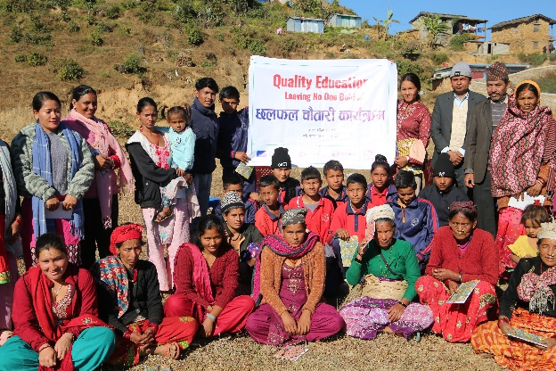
All the parent peer support group members in the project areas have been actively participating in fortnightly awareness-raising sessions. These sessions, facilitated by trained community youth volunteers, are designed to build community knowledge on disability and social inclusion. The sessions (total eight) are based on Save the Children’s awareness-raising toolkit, aligned with the project proposal, and adapted to the local context. A total of 2,313 parents, caregivers, and community members (56% women) participated in these sessions. The session covered topics including social exclusion and discrimination, understanding disability and its classifications, the process for obtaining a disability ID card, government allowances and provisions for persons with disabilities, girls, and marginalized communities, the use of respectful language towards persons with disabilities, barriers in accessing education, and the importance and use of assistive devices. The sessions were conducted in community spaces with active involvement from local government representatives, CSOs, and OPDs, where needed. Parents shared that these sessions have been very helpful, as they previously lacked knowledge about disability rights, social inclusion, and how to access government allowances and support services.
Additionally, these parents’ peer support groups have been linked with Disability Coordination Committees (DCC), ward-level Personal Assistance Service Referral Committees (PASRC), and the Girls Inclusive Education Network (GIEN). This connection ensures that information about services and resources reaches families and helps address community issues through structured forums.
One of the parents, Sukita Rana, shared, "I was never interested in joining meetings or gatherings because of my family situation. I had to take care of my child with a disability, and I felt that others wouldn’t see us positively. But one of the volunteers encouraged me to attend the parents' peer group meeting, and I finally went. There, I saw many other mothers facing similar challenges, and I realized I wasn’t alone. Our volunteer sister shared information about disability, getting an ID card, government support, and how children with disabilities can learn through the School-at-Home program. When the School-at-Home started for my child, I was overjoyed. Earlier, he couldn’t even stand, but now he can. I’ve also been learning physiotherapy from NNSWA staff to support him better. He used to cry a lot, but now he’s happier, interacts with others, and enjoys playing with materials."

A.1.7 Organize child-led roundtables on inclusive and non-violent teaching with child-designed inclusive IEC materials
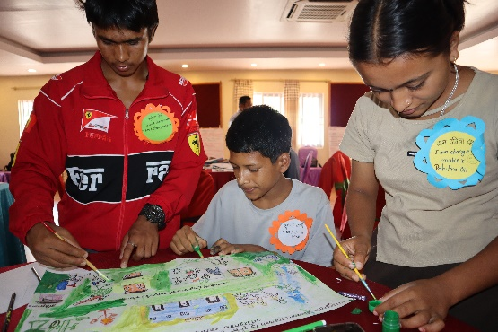
The project organized a three-day capacity development workshop between September and December 2024 in Karnali and Madhesh Provinces, targeting child club members, networks, and EU Youth Sounding Board members. The training was held from 22nd to 24th September 2024 in Surkhet for participants from Karnali and Sudurpaschim Provinces, and from 3rd to 5th December 2024 for participants from Madhesh Province. A total of 41 (Girls: 18, Boys: 23, Madhesi: 10, Brahmin/Chhetri: 15, Tharu: 1, Dalit: 11, Muslim: 2, Janajati: 2 and children with disability: 4) children participated in the workshop, which focused on building leadership and advocacy skills, facilitating round-table discussions, and developing Information, Education, and Communication (IEC) materials on children’s rights to inclusive, equitable, and quality education. During the workshop, children made drawings reflecting their local context, highlighting themes such as access to inclusive education and non-violent teaching practices from their perspectives. Following the training, participants have begun organizing round-table dialogues in their respective Palikas using the child-led IEC materials developed during the workshop. These initiatives demonstrate the children’s enhanced capacity to advocate for their rights and contribute to fostering inclusive education in their communities.
Bipana Bhatta, the member of the child club network, Beldandi, shared her experience after participating in a three-day training on leadership, advocacy, and developing IEC materials. She said, "Before the training, I used to feel shy and lacked confidence to speak in front of others. I thought it was better to stay quiet. But during the training, I learned how to raise children's issues with local government and stakeholders, how to run awareness campaigns in the community, and how to raise my voice about problems that affect children. The trainers gave us lots of encouragement and practical tips on taking leadership roles, speaking confidently, and facilitating meetings. After the training, I led a roundtable discussion as the lead facilitator. I received a lot of appreciation from parents, friends, and even government representatives. That experience really boosted my confidence. Now, I feel more motivated to share my story with friends and take the lead in school extra-curricular and child club activities."

The "Bal Kachahari" (A forum for child-led discussion) roundtable discussion guideline was developed to promote structured, child-led dialogue on improving access to equitable and quality education. In December 2024, two roundtable discussion was organized using this guideline and child-developed IEC materials in Beldandi Kanchanpur, where children facilitated discussions with participation from Palika representatives, police, teachers, and school management committee members. The discussion focused on identifying barriers preventing children—especially girls, Dalits, children with disabilities, and those from poor families—from accessing education. Key issues highlighted included the lack of child-friendly infrastructure in schools for children with disabilities and girls, the impact of child marriage on girls, the increase in drug abuse among teenagers, family conflicts caused by alcohol use, and the inadequacy of government scholarships for girls, Dalits, and children with disabilities. At the end of the discussion, all stakeholders expressed their commitment to support out-of-school children and to ensure schools are gender-sensitive, disability-inclusive, and child-friendly. Participants pledged to continue working on these issues within their roles to help remove barriers and promote inclusive education for all children. The event was attended by 46 participants, including 7 adult females, 9 adult males, 14 girls, and 16 boys, with representation from Brahman/Chhetri (25) and Tharu (21) communities. Although the initial plan was to conduct four roundtable discussions per Palika (a total of 40 events) during the project period, the positive response and impact observed from this first event have led to a decision to organize at least two roundtable discussions per Palika each year which would be 80 in total, utilizing the same budget of project and collaborating with local government. These discussions are becoming important platforms for raising children’s voices, engaging community leaders, and strengthening collective efforts to ensure leaving no one child behind in accessing education.
A.1.8 Establish Model schools, including resource hub.
During this reporting period, the project team held consultation meetings with each Palika to develop indicators for selecting schools aiming to develop them as model schools. These indicators were prepared through discussions with local governments, aligning with national model school selection criteria, while also including inclusive education priorities and adapting them to the local context. After the endorsement by the Palikas, the selection process was carried out under the leadership of local governments. As a result, three model schools were selected from each Palika, totaling 30 schools. The selected schools were formally informed through official letters issued by the respective Palikas. Furthermore, the Palikas expressed their commitment to supporting these model schools by allocating additional resources from their own budgets, in addition to project support. In Year 2, these selected model schools will be supported to establish Inclusive Resource Hubs, providing teachers with resources on inclusive education and tools to improve teaching quality and ensure better access to education for all children.

After the selection of model schools, a three-day workshop was held on 14-16 December 2024 in Karnali Province, in collaboration with the SAHAYATRA III project (SAHAYATRA III is a NORAD-funded integrated project covering education, child protection, child rights governance, livelihood, health, and climate change. It also contributes to the match budget for this project. Two working Palikas—Chhedagadh Municipality of Jajarkot and Shubhakalika Rural Municipality of Kalikot—overlap with this project. SAHAYATRA III also works at the school level, so some activities are organized jointly, and some activities cost-managed by SAHAYATRA III as part of the match budget). During this workshop, 10 teachers from the project areas of Karnali and Sudurpaschim provinces actively participated. The workshop focused on several key topics, including an introduction to inclusive education, steps for establishing inclusive model schools, the development of inclusive resource hubs, stakeholder engagement, advocacy and policy development, and ensuring sustainability of inclusive practices. Through group discussions and interactive sessions, participants worked together to draft minimum indicators for inclusive model schools. These indicators included requirements such as trained teachers, SMC, and the Chairperson of the Parent Teachers Association (PTA) chairs on equity and inclusion; a functional complaint response mechanism; development of equity- and inclusion-informed School Improvement Plans (SIPs); and active child clubs with annual agendas focused on inclusion in education. Participants also identified essential materials for inclusive resource hubs, ensuring these hubs have a minimum enabling environment that supports the participation, learning, and development of all students, including those with diverse disabilities and individual needs. The drafts of both the model school indicators and inclusive resource hub components will undergo further discussion at the Palika level, where local government representatives, school leaders, parents, and CSOs will participate to review and formally endorse them. These documents will become key reference points for the development and monitoring of model schools and resource hubs. The workshop for Madhesh Province is planned for Year 2.

Output 2:
A.2.1 Assess co-applicants’ capacities and develop tailored training and mentoring plans including in GESI and disability inclusion
In August 2024, the project carried out an Organizational Capacity Assessment (OCA) of its Partner Non-Governmental Organizations (PNGOs) using Save the Children’s standard tool. This assessment focused on nine key areas: governance, people, project management, systems, resources, influence, quality, participation, and legitimacy. In addition to this, a customized tool was developed and used to specifically assess the status of each partner organization regarding Gender Equality, Disability, and Social Inclusion (GEDSI). The assessment process was collaborative, with scores reviewed and agreed upon through discussions with Save the Children (SC), ensuring accuracy through evidence verification. Following this process, each PNGO developed an organizational capacity development plan, tailored to address identified gaps. These plans are designed to be reviewed and updated every two years, allowing for continuous monitoring and improvements.
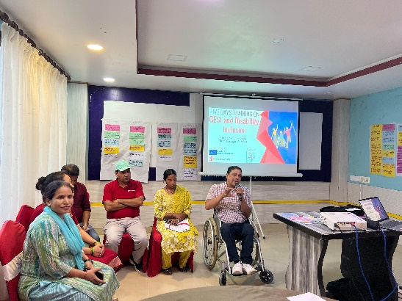
Building on these assessments, a five-day capacity-building training was organized on 13-17 August 2024 in Surkhet for the board members and project staff of partner organizations. A total of 13 participants (4 women, 9 men; Brahman/Chhetri: 5, Dalit: 2, Madhesi: 3, Tharu: 1, and Muslim: 2) took part in the training. The content was designed based on the findings from the OCA and aligned with the project’s overall goals. The training addressed common biases and knowledge gaps around disability, gender equality, and social inclusion, equipping participants with the understanding needed to apply inclusive practices in their daily work. Key topics covered included equity and inclusion in education, alongside national policies and frameworks such as the School Education Sector Plan (SESP), Equity Strategy, Equity Index, GIEN, and Recovery and Accelerated Learning (ReAL) Plan. Participants shared that the training gave them greater clarity on these policies and practices related to GEDSI, and how to integrate them into both their organizational responsibilities and project activities.
To ensure the continuous capacity strengthening of the partner organizations (PNGOs), mentoring plans have been developed for both NNSWA and StS, led by RCRD. These mentoring sessions are being delivered through a combination of in-person meetings, onsite coaching and virtual support, contributing to the ongoing growth and capacity enhancement of both organizations. This structured mentoring approach is helping them to integrate equity and inclusion principles more effectively into their operations and project activities, resulting in smoother and more inclusive project implementation. Additionally, the project has established virtual weekly meetings, led on a rotational basis by different PNGOs. These meetings focus on providing technical clarity, sharing learnings, setting priorities, and reviewing work methodologies and progress. This regular practice not only fosters teamwork and coordination but also plays a significant role in the continuous capacity development of the entire project team, ensuring alignment and consistent quality across all project interventions.

A.2.2 Train target CSOs in advocacy skills, GESI and the Equity Strategy Implementation Plan
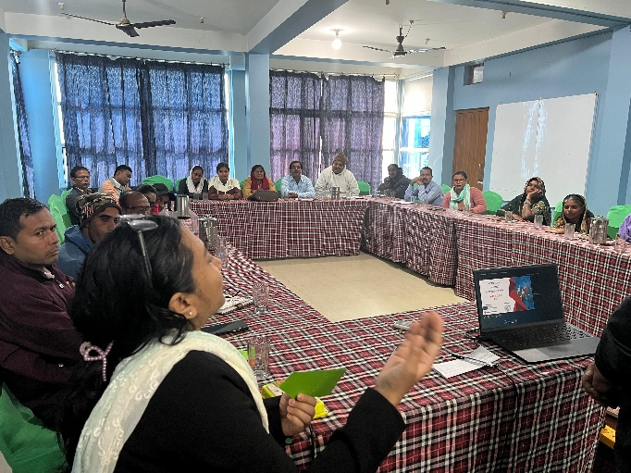
Ten community-based Civil Society Organizations (CSOs) have been selected to provide financial support through the Financial Support to Third Parties (FSTP) process. To strengthen their capacity, two separate four-day training sessions were organized between November and December 2024. The first training was conducted from 7th to 10th November 2024 in Kanchanpur, Sudur Paschim Province, for participants from CSOs in Karnali and Sudurpaschim Provinces, and the second training was conducted from 22nd to 25th November 2024 in Lahan, Siraha for participants from Madhesh Province. The training content was designed based on the capacity assessments of each CSO, covering key topics such as advocacy for inclusive policies and their implementation, disability rights, gender equity and social inclusion (GESI), leadership development, and resource mobilization and utilization.
Additionally, the sessions provided detailed guidance on the FSTP process, including how to develop and implement effective action plans focusing to equity and inclusion. In total, 45 CSO members (15 women and 30 men; 15 from Madheshi, 16 Brahman/Chhetri, 3 Tharu, 5 Dalit, 4 Muslim, 2 Janajati, 2 disability) participated in the training. At the end of the training, all participants developed action plans tailored to their organizational priorities. These plans included activities such as consultations with Palikas on inclusive policies and provisions, community-level awareness campaigns, and school enrolment campaigns aimed at improving education access for marginalized children. This process has not only built the knowledge and skills of local CSOs but has also positioned them as key partners in promoting inclusive education and social inclusion in their respective communities.
One of the CSO Chairperson, Mohammad Saphikula Ansari, shared, “We had formed our organization and registered it at the District Administration Office, but until now, we hadn't received any training or support—we only conducted our annual general assembly to renew the organization. When we heard about the opportunity to submit proposal for Financial Support to Third Parties (FSTP) through Save the Saptari (StS), we applied and got selected. After being selected, we were invited to attend training on leadership, advocacy, resource mobilization, and financial management. This training gave us valuable knowledge on how to manage our organization in a more systematic way. We are also getting regular support from StS. Our organization went through a capacity assessment (OCA), and we have now developed capacity development plan. With all this support, we have started working more closely with the local government, especially to raise issues affecting children with disabilities, girls, Dalits, and other marginalized communities. The Palika has been responsive and has shown a commitment to support and implement our shared action plan. I’m really happy that our organization is getting this chance to grow and make a difference.”

A.2.3 Promote an accelerator fund (FSTP) for target CSOs & grassroots initiatives/youth networks to champion SBC campaigns and community action planning for equity and inclusion in education
To strengthen community engagement and promote inclusive development, ten community-based Civil Society Organizations (CSOs) were selected for Financial Support to Third Parties (FSTP) in collaboration with local governments. These CSOs represent diverse groups, including two organizations of Persons with Disabilities (OPDs), three youth-led organizations, and five women-led organizations. One CSO has been selected from each Palika of the project’s working areas. The selection process followed the Save the Children partnership guideline, and the guideline outlined in the project proposal, including the publication of Expressions of Interest (EOI) and information sessions. The implementation of FSTP is planned for Year 2. However, following their selection, CSOs have been actively engaging in community-level activities and coordinating and collaborating with Palikas. A notable achievement is that a CSO in Laljhadi named Aadibasi Janajati Sangh secured NPR 250,000 from the Palika, demonstrating successful local resource mobilization. Additionally, other CSOs have submitted their proposals to Palikas for the upcoming fiscal year, aiming to integrate their equity and inclusion initiatives into local government budgets. This financial support will enable CSOs to implement their own plans, ensuring sustainable and locally driven impact. By equipping CSOs with the necessary resources and fostering strong partnerships with local governments, this initiative aims to enhance inclusive development, empower marginalized groups, and strengthen grassroots advocacy efforts for lasting change.
All the CSOs have developed their annual plan covering the community action plan that will be implemented by the FSTP support. The action plan included awareness raising on children's education-related issues, girls’ education, harmful gender and cultural norms (i.e., child and early marriage), education for Children with Disabilities, education for girls, Dalit and marginalized communities, etc. Also, activities that are led by people or children with disabilities, women/girls, and other marginalized groups will be prioritized.
A.2.4 Organize exposure visits to model schools for target stakeholders
Not applicable as this activity is planned for Year 2.
A.2.5 Support Youth-led participatory Action research (YPAR) to identify barriers to access and retention of children in education and support with project monitoring
Not applicable as this activity is planned for Year 2 and Year 3.
A.2.6 Engage graduate students from KUSoED through a fellowship programme on equity and inclusion in education
Not applicable as this activity is planned for Year 2 and Year 3.

Output 3:
A.3.1 Engage target CSOs in Palika pre-planning and budgeting discussions to identify and prioritise immediate education needs
The local government planning and budgeting process was already completed by the time the project started, so the project team couldn't engage in the planning process. Additionally, CSOs were selected later, so they were also not involved in the local government planning process. For this year's planning process, the project has already started discussions with CSOs, Child Clubs, GIEN, DCC, and PASRCs to facilitate the development of their annual costed action plans and priorities related to equity and inclusion. These plans will be submitted to the local government with a request to include them in the local government program and allocate resources for their implementation.
One CSO in Laljhadi has already influenced the local government and received Rs 25,000 (equivalent to EURO 160) through this year's current budget to implement their annual action plan related to inclusive education. CSOs are engaging and closely coordinating with the local government, seeking space in local-level planning and budgeting, and advocating for the formulation or revision of local education policies, strategies, and plans to make them more inclusive.
A.3.2 Strengthen existing Girls and Inclusive Education Network (GIEN) and disability-related committees at ward/palika levels to facilitate community level disability services
The project aimed to strengthen local governance structures to promote gender and disability inclusion at the ward and Palika levels. Many existing gender and disability-related networks were either inactive or non-existent, limiting the support available for marginalized groups. To address this, 10 one-day orientation was conducted at the palika-level from July to August 2024 for local government and ward officials to enhance their understanding of gender and disability-related networks and committees. This orientation aimed to improve community-level gender and disability services by clarifying the roles and responsibilities of local officials.
As part of efforts to promote inclusive education for girls, the project facilitated the formation of Girls Inclusive Education Networks (GIEN) in all ten-project working palikas. This initiative aligned with government guidelines that mandate the establishment of GIEN networks at the Palika level. However, it was observed that many Palikas either lacked these networks or had inactive ones. To ensure clarity in their roles, the project organized a one-day orientation for GIEN members, covering key topics such as barriers to girls' education, the responsibilities of parents, schools, and local governments, and the role of GIEN members in ensuring education rights for girls. A total of 243 participants attended, including 75 females, 144 males, 14 girls, 10 boys, and 13 persons with disabilities, reflecting diverse community involvement.
Following these meetings, all GIEN networks developed their annual action plans for 2025, focusing on addressing key challenges and advocating for gender-inclusive education policies at the Palika level. These plans also emphasized the development of gender-friendly School Improvement Plans (SIPs) and the creation of a safe and supportive school environment for girls. Strengthening these networks is expected to foster a more inclusive and equitable educational landscape, ensuring that girls have access to safe, supportive, and quality education.
Additionally, the project facilitated the formation/ reformation, and activation of Disability Coordination Committees (DCC) at the Palika level in all project areas, along with formation of 87 Personal Assistance Service Referral Committees (PASRC) at the ward level. These committees have been established based on existing government guidelines. To ensure effectiveness, the project conducted a one-day orientation on various dates from September 2024 to February 2025 for DCC and PASRC members, clarifying their roles and responsibilities and facilitating them in developing their annual action plans. Strengthening these networks and committees will enhance the accessibility of gender and disability services at the community level and contribute to systemic changes in education and social inclusion.

A.3.3 Organize annual province-level, multi-stakeholder equity and inclusion in education discourses
Although the project’s official start date is 1 March 2024, the project actually began implementation after June 2024 due to delays in onboarding partners and staff. Consequently, it took time to generate proven good practices and model school initiatives. Hence, the provincial-level discourses are planned for Year 2, as these discourses were intended to share good practices and model school initiatives. Similarly, the provincial-level education discourses have also been rescheduled for Year 2.
Despite these delays, the project successfully organized key events, including a provincial-level project kick-off meeting, an annual project review and sharing meeting, and collaborative engagements with other development organizations. Notably, the project partnered with the Society for Integrated Alliance Nepal to initiate dialogues on inclusive education at the provincial level in Karnali Province. Furthermore, the project team actively participated in the EU-organized education dialogue at the federal level, ensuring alignment with national education priorities and contributing to the education act at the federal level, as well as contributing to the development of education policies and plans for Karnali and Madhesh provinces. These efforts have established a strong foundation for future advocacy and collaboration, setting the stage for more impactful engagements in the coming years.

A.3.4 Organize annual joint palika/province education planning and financing monitoring meetings
In December 2024, the project conducted joint monitoring visits across ten Palikas with the active involvement of the Municipal Project Advisory Committee. The committee included representatives from local government officials, Disability Coordination Committee (DCC), Municipal Education Committee, media, Civil Society Organizations (CSOs), Organizations of Persons with Disabilities (OPDs), and child/youth organizations and networks. A total of 274 participants took part in these visits (Female: 70, Male: 202, Girl: 2; Madhesi: 48, Brahmin/Chhetri: 161, Tharu: 5, Dalit: 34, Muslim: 8, Janajati: 18, person with disability: 8). During the monitoring, the committee observed the project’s progress, identified issues and challenges, and discussed potential ways forward. Key suggestions from the monitoring include:
- Expanding the coverage of out-of-school children (particularly who could not attend school physically) through the School-at-Home program.
- Supporting the development of girl- and disability-friendly infrastructure in schools.
- Enhancing the use of digital technology in schools to improve teaching and learning.
The feedback and recommendations gathered during these monitoring visits will be utilized by the project team within the scope of the project. Furthermore, this will be discussed in the palika level meeting to integrate these findings into their planning and budgeting processes to sustain the outcomes of the project.

In addition, monitoring was conducted by the Youth Sounding Board members across project areas in all three provinces. They observed project interventions and appreciated project beneficiaries’ selection process and initiatives such as the School-at-Home program, parents peer support group formation, youth volunteer mobilization in awareness raising activities, working with community based CSOs. They provided further recommendations, including:
- Integrating technology into teaching and learning activities.
- Instituting awards to recognize the best facilitators of the School-at-Home program, such as parents who have demonstrated good examples.
A.3.5 Gather evidence from the project for bottom-up advocacy with the MoEST on inclusive education policy/plans implementation and financing
Not applicable as this activity is planned for Year 2 and Year 3.

  - Logframe matrix updated

Results | Results chain | Indicator | Baseline  (Y1) | Target  (value & reference year) | Current value*  (Y1)  (* to be included in interim and final reports) | Sources of data | Assumptions
 | Overall Objective: To improve the participation of civil society in the education sector to increase effective and inclusive implementation of the national education policy | Number of government policies/strategies/plans developed or revised with civil society organisation participation through EU support* (with a focus on equity and inclusion) | 0 (Y1) | 10 (Y4) | 0 (Y1)  This will be reported at the project end | Progress Report, meeting minutes, attendance lists, Government publications | Not applicable
 | Specific Objective: To strengthen civil society’s role in promoting inclusive access to quality education for all | % increase in knowledge of target CSO representatives on equity and inclusion in education policy implementation compared to baseline (disaggregated by sex, disability, and ethnicity) | 0 Y1 | 30% Y4 | This will be assessed during the endline survey | Training reports, test scores, endline | Civil society organizations prioritize and are willing to engage in promoting equity and inclusion in the education sector.  All tiers of government provide enabling environment for CSOs to engage and function in the education sector.
 |  | % of identified out-of-school children (age 5-12) in catchment area who are enrolled in Basic Education (disaggregated by sex, age, ethnicity, disability) | 139 out of school children identified  (Girls: 73, Boys: 66 and children with disabilities: 73, Ethnicity-wise, there are 21 Brahmin/Chhetri, 41 Dalit, 26 Janajati, 26 Muslim, 22 Terai Madheshi, and 3 others.) | 80% Y4 | 44 Children enrolled  31.6% (Y1)  (Girls:22, Boys: 22 and children with disabilities: 26, Ethnicity-wise, Brahman/Chhetri :8, Dalit : 18, Janajati: 13, Muslim: 3, Other, Terai Madhesi: 2, ) | Baseline and Endline Survey, enrolment will be tracked each year, progress reports, school records
 | Output 1: Opportunity costs and social-norm-driven barriers to accessing education are reduced through locally led solutions | Number of teachers, members of  SMC, PTA and parents oriented/trained on equity and inclusion in education (disaggregated by sex, disability) | 0 (Y1) | 2,150 (Y4) | 0 (Y1)  Planned for Y2 and Y3 | Event reports/ project progress report, SMC records | Education stakeholders and community members recognize the value of equity and inclusion in education are accepting of changes that challenge deeply rooted cultural and social norms  CSOs are able to apply their advocacy skills and secure matching fund from the government.
 |  | Number of model schools for equity and inclusion in education established | 0 (Y1) | 30 (Y3) | 30 model schools are selected (Y1) | Project progress report, case studies
 |  | Number of palikas/cooperatives that establish funding mechanisms to support vulnerable and out of school children | 0 (Y1) | 10 (Y4) | 0 (Y4)  This is planned for Y2 and Y3 | Project progress report, scholarship fund selection criteria
 | Output 2: Civil society and youth’s capacity to drive equity and inclusion in education is increased | Number of youth-led research pieces on equity and inclusion in education produced | 0 (Y1) | 4 (Y4) | 0 (Y1)  This is planned for Y3 | YPAR action research brief, KUSoED research reports | Youth and OPD are available and committed to work as change agents.  Government is more responsive if the CSOs including OPDs and youth systematically advocate with them.
 |  | Number of grassroots civil society organisations benefitting from (or reached by) EU support* | 0 (Y1) | 10 (Y4) | 10 (Y1) | Project progress report, FSTP records
 | Output 3: Coordination between civil society and the three levels of Government in the education sector is enhanced | Number of local level equity and inclusion structures formed/reformed and activated | 11 (Y1)  (Disability Coordination Committee- 10  Personal Assistance Service Referral Committees- 0  Girls and Inclusive Education Network- 1) | 107 (Y4) (Disability Coordination Committee- 10, Personal Assistance Service Referral Committees – 87, Girls and Inclusive Education Network – 10) | 107 (Y1) (Disability Coordination Committee- 10, Personal Assistance Service Referral Committees – 87, Girls and Inclusive Education Network – 10) | Project progress report, meeting minutes | Civil space is intact, and government (at all levels) is willing to engage with CSOs on formulation of policies/plans, and support structures at all levels.  Government willing to allocate and proper utilization of budget for equity and inclusion in education.
 |  | Number and diversity of CSOs invited/participating in/contributing to national, provincial, and local/sectoral development plan/strategy policy discussions or consultations on draft laws/policies | 0 (Y1) | 10 CSOs (at least 5 OPDs, 5 women and youth-led) (Y4)  Update on output target: The number of targeted CSOs has been changed from 15 (as per final LF) to 10. The log-frame as per contracts sets a target of selecting 15 CSOs. However, after meeting with local governments (Palikas), they advised selecting only one CSO per Palika. The local governments explained that having more than one CSO in the same Palika could cause challenges, such as difficulties in participation, resource allocation, and division of working areas, which might create conflicts between CSOs.  Additionally, the Palikas shared that there are very few CSOs working in equity and inclusion. This was confirmed during the Expression of Interest (EOI) process, where the projecct found that in most Palikas, only one or two CSOs applied, and very few were focused on equity and inclusion.  The project proposal, under Activity A.2.3 ("Promote an accelerator fund (FSTP) for target CSOs and grassroots initiatives/youth networks to champion SBC campaigns and community action planning for equity and inclusion in education"), mentions selecting between 10 and 15 CSOs. Likewise, under the FSTP approach, it is mentioned in the Expected Results section that 10–15 recipient organisations are expected to be supported.  Based on the feedback from the local governments and the budget available under the FSTP, the project landed on selecting 10 CSOs - one in each Palika—so that the project can provide more support to each CSO and achieve better results at scale. | 0 (Y1)  This is planned for Y2 and Y3 | Project progress report, meeting minutes, attendance lists of meetings/events

  - Activity Matrix

Output 1:  A.1.1 Community-led disability awareness and action planning  A.1.2 Promote disability screening campaigns at ward level and referrals to relevant health & social protection services  A.1.3 Expand revenue streams (public/private) in the form of need-based scholarship and bursary support for children  A.1.4 Training for model schoolteachers/SMC/PTA members on equity and inclusion in education for upgrading SIPs  A.1.5 Orientation of non-model school SMC/PTA members on equity and inclusion in education  A.1.6 Establish parent peer-support groups  A.1.7 Organize child-led roundtables on inclusive and non-violent teaching with child-designed inclusive IEC materials  A.1.8 Establish Model schools, including resource hub.  Output 2:  A.2.1 Assess co-applicants’ capacities and develop tailored training and mentoring plans including in GESI and disability inclusion  A.2.2 Train target CSOs in advocacy skills, GESI and the Equity Strategy Implementation Plan  A.2.3 Promote an accelerator fund (FSTP) for target CSOs & grassroots initiatives/youth networks to champion SBC campaigns and community action planning for equity and inclusion in education  A.2.4 Organize exposure visits to model schools for target stakeholders  A.2.5 Support Youth-led participatory Action research (YPAR) to identify barriers to access and retention of children in education and support with project monitoring  A.2.6 Engage graduate students from KUSoED through a fellowship programme on equity and inclusion in education | Means  Human resources:  Number of technical personnel:  Partner CSO: technical staff 13, admin/support staff 9  SC: technical staff 11, admin/support staff 11.  Material: 11 laptops, 1 projector, 1 printer, 4 sets of furniture  FSTP: 10 grants (In total 20 FSTP grants will be supported. These will be provided in two instalments in Y2 and Y3. So, the total will be 20 FSTP grants).  Events (meetings, trainings): 617  Premisses of all partners will be made available for coordination meetings etc.  KUSoED premisses will be available for the graduates for their research work.  Content creation for media dissemination.  ICE materials and dissemination publications.  Costs  What are the action costs? How are they classified? (Breakdown in the Budget for the Action)  - Human resources – 577,734 EURO (40 % of total cost)  - Travel – 60,343 EURO (4% of total cost)  - Equipment and supplies – 15,968 EURO (1% of total cost)  - Project office – 39,530 EURO (3% of total cost)  - Other costs, services – 14,800 EURO (1% of total cost)  - Other – 635,083 EURO (44% of total cost) | Assumptions  External, necessary and positive conditions for implementing the intervention that are outside of its management's control.  CSOs staff and other stakeholders show willingness to work as a team and demonstrate interest in the activities  Government recognizes the role of CSOs in education sectors, especially OPDs and children and youth.  Local level youth will be motivated and encouraged to work to promote equity and inclusion in education as a result of interaction with youth sounding board and research fellows

  - Updated action plan for the future activities of the project

Year – 2025
 | Half-year 1 |  |  |  |  |  | Half-year 2
Activity. | 3 | 4 | 5 | 6 | 7 | 8 | 9 | 10 | 11 | 12 | 1 | 2 | Implementing body
1.1.4.1 Organising community awareness raising sessions (Ward level) |  |  |  |  |  |  |  |  |  |  |  |  | NNSWA and StS
1.2.2.1 Orientation to local government representatives on how to conduct disability screening |  |  |  |  |  |  |  |  |  |  |  |  | NNSWA and StS  Technical support by RCRD
1.2.3.1 Orientation to local government representatives on sub-system of reporting the students with disabilities in IEMIS |  |  |  |  |  |  |  |  |  |  |  |  | NNSWA and StS  Technical support by RCRD and Save the Children
1.2.4.1 Supporting to local governments on organizing disability screening camp |  |  |  |  |  |  |  |  |  |  |  |  | NNSWA and StS  Technical support by RCRD and Save the Children
1.3.1.1 Provision of FSTP to Local governments in 10 Palika (Matching fund) |  |  |  |  |  |  |  |  |  |  |  |  | NNSWA and StS  Technical support by Save the Children
1.3.2.1 Educational Materials/ bursary support to marginalized children |  |  |  |  |  |  |  |  |  |  |  |  | NNSWA and StS
1.4.1.1 SMCs PTAs, Head teacher training of model School on Equity in inclusion education (Including 2 days refresher training) |  |  |  |  |  |  |  |  |  |  |  |  | NNSWA and StS  Technical support by RCRD and Save the Children
1.4.2.1 Training to the model school teacher on training on non-violent teaching & Child Friendly methods |  |  |  |  |  |  |  |  |  |  |  |  | NNSWA and StS  Technical support by RCRD and Save the Children
1.4.3.1 School based SIP/ASIP upgrading workshop to model school |  |  |  |  |  |  |  |  |  |  |  |  | NNSWA and StS  Technical support by RCRD and Save the Children
1.5.1.1 Orientation to non-model school SMCs, PTAs on social and disability inclusion (School based event) |  |  |  |  |  |  |  |  |  |  |  |  | NNSWA and StS  Technical support by RCRD and Save the Children
1.6.1.1 Form parents support groups and organize chhalphal chautari |  |  |  |  |  |  |  |  |  |  |  |  | NNSWA and StS
1.7.3.1 Organize Bal Kachahari |  |  |  |  |  |  |  |  |  |  |  |  | NNSWA and StS
1.8.1.1 Workshop to develop model school indicators including resource hub check list and support inclusive materials to model schools to establish resource hub |  |  |  |  |  |  |  |  |  |  |  |  | NNSWA and StS  Technical support by RCRD and Save the Children
1.8.2.1 School-at-home material support |  |  |  |  |  |  |  |  |  |  |  |  | NNSWA and StS
1.8.4.1 NNSWA - Remuneration to the facilitators of School-at-Home |  |  |  |  |  |  |  |  |  |  |  |  | NNSWA and StS
1.8.5.1 School based orientation to the teacher on the use of attendance audit application |  |  |  |  |  |  |  |  |  |  |  |  | NNSWA and StS  Technical support by RCRD and Save the Children
1.8.6.1 Match fund for inclusive infrastructure support (construction & renovation) |  |  |  |  |  |  |  |  |  |  |  |  | NNSWA and StS  Technical support by RCRD and Save the Children
1.8.7.1 Orientation to the schools on Vcop |  |  |  |  |  |  |  |  |  |  |  |  | NNSWA and StS  Technical support by Save the Children
2.2.2.1 Review and reflection meeting with CSOs |  |  |  |  |  |  |  |  |  |  |  |  | NNSWA and StS
2.3.1.1 Accelerator fund to third parties (FSTP) |  |  |  |  |  |  |  |  |  |  |  |  | NNSWA and StS  Technical support by Save the Children
2.3.1.2 Information session for FSTP Accelerator fund to third parties (FSTP |  |  |  |  |  |  |  |  |  |  |  |  | NNSWA and StS
2.4.1.1 Exposure visit (District Wise) |  |  |  |  |  |  |  |  |  |  |  |  | NNSWA and StS
2.5.1.1 Youth led action research to identify barriers to access & retention of Children in education |  |  |  |  |  |  |  |  |  |  |  |  | NNSWA and StS  Technical support by Save the Children
3.1.1.1 Engage target CSOs in Palika pre-planning and budgeting discussions to identify and prioritize immediate education needs |  |  |  |  |  |  |  |  |  |  |  |  | NNSWA and StS  Technical support by RCRD and Save the Children
3.2.1.1 Orientation to LG officials and representatives and formation of Girls and Inclusive Education Network (GIEN) |  |  |  |  |  |  |  |  |  |  |  |  | NNSWA and StS  Technical support by RCRD and Save the Children
3.2.2.1 Orientation to Ward Representatives on Forming Ward level Disability Assistance Committee |  |  |  |  |  |  |  |  |  |  |  |  | NNSWA and StS
3.3.1.1Provincial level education discourse |  |  |  |  |  |  |  |  |  |  |  |  | NNSWA and StS  Technical support by RCRD and Save the Children
3.4.1.1 Annual Joint Monitoring Visit |  |  |  |  |  |  |  |  |  |  |  |  | NNSWA and StS
3.4.2.1 Annual Joint Palika/Province Education Financing Monitoring Meetings |  |  |  |  |  |  |  |  |  |  |  |  | NNSWA and StS
3.5.3.1 Organize dissemination event of the learning and good practices |  |  |  |  |  |  |  |  |  |  |  |  | NNSWA and StS  Technical support by RCRD and Save the Children

2.6 Where relevant, please provide any update to the self-evaluation questionnaire on SEA-H and related list of envisaged measures to improve the SEA-H policy within the organisation.

This is not applicable.

- Beneficiaries/affiliated entities, trainees and other cooperation
  - How do you assess the relationship between the beneficiaries/affiliated entities of this grant contract (i.e. those having signed the mandate for the coordinator or the affiliated entity statement)? Please provide specific information for each beneficiary/affiliated entity.
The project was officially signed on 1 March 2024 between Save the Children Norway and Nepal, followed by a virtual kick-off meeting in April 2024, where project-related information and compliance requirements were shared. To ensure continuous coordination, bi-monthly project meetings are conducted to discuss updates, lessons learned, challenges, and future plans. Technical support is provided as needed by Save the Children Norway (SCN) technical advisors, ensuring timely assistance through direct engagement with the country office. Regular communication is maintained via email, facilitating smooth collaboration. Additionally, during a visit to Nepal for another purpose, Save the Children Norway (SCN) project focal engaged in discussions on project progress, learnings, challenges, and future strategies. This reflects a strong, ongoing partnership between the implementing organization and SCN, ensuring close coordination, timely technical support, and a well-established working relationship between the two entities.
The project is being implemented through a partnership between NNSWA, StS, and RCRD, with technical support from Save the Children Nepal. NNSWA is responsible for implementing the project in six Palikas of Karnali and Sudurpaschim Province, while StS is leading implementation in four Palikas of Madhesh Province. RCRD, as a technical resource organization specializing in disability, provides expertise and guidance on disability-related components of the project. Additionally, Kathmandu University is an associate partner, with planned activities scheduled to begin in Year 2.
All partner organizations have successfully completed their assigned tasks in accordance with the sub-award agreements, ensuring compliance with project operation guidelines and timelines. Save the Children Nepal plays a key role in providing technical support based on the project’s technical support plan. Weekly virtual meetings are conducted to review progress, discuss learnings and challenges, clarify technical aspects of activities, and set priorities for the upcoming week. In addition, Save the Children carries out monthly financial voucher verifications and periodic monitoring, including comprehensive compliance monitoring, joint monitoring, and regular technical field visits, and provides onsite coaching & support.
The project has developed the Quality Benchmark (QBM) of all the project activities and follows it diligently, where the Monitoring, Evaluation, Accountability, and Learning (MEAL) coordinators from Save the Children and MEAL officers from partner organizations regularly monitor activities based on the QBM. If any area needs improvement, action plans are developed to address them. Furthermore, the project holds annual review meetings, where representatives from the European Union (EU) and Save the Children thematic advisors provide insights and recommendations for enhancing project outcomes.
Partner organizations (PNGOs) have responded positively to feedback and actively integrate these suggestions into their implementation strategies. They also proactively seek technical support from Save the Children Nepal and RCRD as needed, ensuring continuous improvement in project execution. This strong coordination and collaboration between Save the Children and the implementing partners have resulted in an effective and productive working relationship, contributing to the successful implementation and impact of the project.
The partnership sub-award process has been completed following a structured and transparent approach. Before agreements are signed, the executive board members and key personnel of partner organizations working with Save the Children International (SCI) undergo a vetting process conducted by the legal team. Once approved, a partner record is created in SCI’s Award Management System to maintain systematic documentation.
To assess and strengthen partner organizations, an organizational capacity assessment was conducted using Save the Children’s standard tool. This assessment evaluated both general organizational capacity and project-specific capabilities, leading to the development of tailored capacity development plans. These plans help ensure that partners have the necessary resources and skills to effectively implement project activities.
Partnership agreements were carefully reviewed, fully explained, and negotiated with each partner before being finalized. The agreements were signed at the relevant level within SCI and by both parties before the transfer of funds or the start of joint programming activities. The agreements also included essential annexes such as the scope of work, budget, fund release plan, and capacity strengthening plan. Additionally, SCI’s mandatory policies were incorporated, including the Child Safeguarding (CSG) Policy, Anti-Harassment, Intimidation, and Bullying Policy, Protection from Sexual Exploitation and Abuse (PSEA) Policy, Fraud, Bribery, and Corruption Policy, Human Trafficking and Modern Slavery Policy, and donor compliance conditions.
At the beginning of the project, SCI organized a project kick-off workshop in collaboration with co-applicants. This workshop ensured that all partners fully understood the project’s requirements, implementation strategies, and donor compliance standards. By establishing clear guidelines and expectations from the outset, the partnership framework has contributed to smooth coordination, effective implementation, and adherence to compliance standards, strengthening the overall impact of the project.

  - How would you assess the relationship between your organisation and State authorities in the action countries? How has this relationship affected the action?
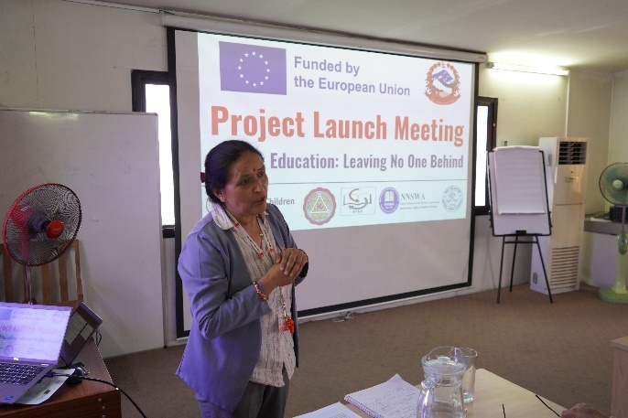
The relationship between the project and state authorities in the project implementing areas has been highly collaborative and constructive, fostering strong partnerships for effective implementation. The active participation of government stakeholders in the project launch meetings, held at both national and Palika levels, reflects a shared commitment to addressing education challenges for children with disabilities, girls and marginalized groups, and those at risk of dropping out. These meetings, organized in June and July 2024, brought together government representatives, school officials, CSO members, and other I/NGO partners, providing a platform to establish common goals, align priorities, and clarify roles. The enthusiasm and commitment expressed by all ten Palikas to work closely with the project indicate a strong foundation for cooperation.
To formalize this partnership, a tripartite agreement has been done in all working Palikas, clearly defining the roles and responsibilities of Save the Children, implementing partners, and local governments. This agreement has facilitated resource-sharing, policy alignment, and coordination on key education interventions, such as developing inclusive resource hubs in model schools, training teachers, School Management Committee (SMC) members, and parents, strengthening civil society organizations, conducting disability screening camps, and implementing the School-at-Home program. The engagement of state authorities in these efforts has significantly contributed to the project's success by enhancing credibility and acceptance at the local level, ensuring better coordination between government programs and project activities, increasing access to government resources for children with disabilities, girls, and marginalized groups, and promoting long-term sustainability through government-led initiatives.
Chandra Bahadur Thapa, Mayor of Bheri Municipality, says, "Bheri Municipality is one of the areas severely impacted by the earthquake on November 3, 2023, in Jajarkot, which resulted in the destruction of many households and schools. While several organizations are providing relief support, we lack guidance and technical support on inclusive education and ensuring children's right to education. This EU-funded project focuses on inclusive education and the right to education. We are eager to collaborate with this project and will put forth our best efforts to ensure the right to education for all children and to create an inclusive, quality learning environment in our schools."
Likewise, periodic joint project monitoring and review meetings have further strengthened coordination and collaboration between the project and local governments. These monitoring and review meetings provided a platform to discuss best practices, key learnings, and areas for improvement. As a result of these discussions, several local governments have committed to scaling up the School-at-Home program, allocating resources to CSOs, creating girls and disability friendly school environment, actively participating in various community-level activities, sharing information, and commitments from the government side. Additionally, they have expressed their dedication to incorporating the project’s best practices into their own policies and plans, ensuring long-term sustainability.
By prioritizing girls, Dalit children, children from poor households, and children with disabilities, the project remains aligned with national education policies and local government priorities, further strengthening mutual cooperation. The commitment of local governments to sustaining these initiatives beyond the project's completion reinforces its long-term impact, creating a more inclusive and equitable education system for all children.
At the provincial level, the project has closely coordinated with the Ministry of Social Development (MoSD), particularly the Education Development Division and the Education Development Directorate (EDD), ensuring active government participation in key project activities such as kick-off meetings, reviews, and sharing sessions. Additionally, the project provided technical support in the development of Karnali Province’s ten-year education plan, aligning project initiatives with provincial education priorities and fostering a more supportive implementation environment.
At the national level, the project has worked in close collaboration with the Ministry of Education, Science, and Technology (MoEST) and the Center for Education and Human Resource Development (CEHRD). One of the key joint initiatives has been the rollout of the Integrated Educational Management Information System (IEMIS) training. In coordination with CEHRD, the project facilitated training for Palika education officers, who then trained school teachers, thereby strengthening the reporting of data on children with disabilities through the IEMIS system.
Additionally, the project engaged CEHRD in the development of a Universal Design for Learning (UDL) flip chart in collaboration with CEHRD. This resource will be uploaded to the CEHRD website and printed for wider distribution beyond the project areas, ensuring a broader impact on inclusive education. CEHRD has also actively monitored the School-at-Home program and, recognizing its effectiveness, has incorporated it as one of the approaches in the draft Inclusive Education Strategy. This ensures that no child is left behind and that children’s right to education is upheld.
These collaborative efforts at all levels have strengthened policy alignment, enhanced implementation efficiency, and contributed to the sustainability of key project initiatives by integrating them into government education frameworks.
  - Where applicable, describe your relationship with any other organisations involved in implementing the action:
Associate(s): Kathmandu University is the associate partner for this project, serving as a technical research partner. They will support the design of activities related to research and fellowship programs concerning equity and inclusion in education. This activity is planned to be implemented from Year 2. However, they are invited to the project kick-off, annual review reflection workshop for learning sharing, and also to informed them about the project work from the initial phase.

- Contractor(s) (if any): The consultant hired under this project from March 2024 to February 2025 are as below:

Name of the firm | Assignment undertaken
Sky Hub Pvt Ltd and Shaalin Film Production | Video and Photos for Baseline Situation Assessment
Dr. Birendra Raj Sharma Pokharel | Facilitate three days training on Inclusive Education, focusing on developing inclusive model schools and establish inclusive resource hubs
Divyata Creatives | Project two-pager design
Sewa press | Project two-pager printing
Topnath Neupane and  Sambridhi Shrestha | Sign Language Interpretation (SLI) and closed captioning for the celebration of the International Day of Persons with Disabilities on December 9, 2024.

Final beneficiaries and target groups: To date, our engagement with beneficiaries and target groups has been built on mutual respect, accountability, effective communication, and trust. This strong foundation has fostered collaboration and commitment toward achieving shared goals. The project has directly reached a total of 10,533 children, ensuring inclusive participation across diverse groups.

Other third parties involved (including other donors, other government agencies or local government units, NGOs, etc.): The project has fostered strong working relationships with various organizations, including government agencies, NGOs, and international partners. Key collaborators include the Society for Integrated Alliance (SIAN), Pachtara Yuwa Samrakshak Manch (PTYSM), Village Development and Save the Environment Forum (VDSEF), and the National Federation of the Disabled Nepal (NFDN) along with its provincial and municipal chapters. Additionally, partnerships with EU-partner organizations such as People in Need (PIN), the National Campaign for Education (NCE), UNICEF, and the Embassy of Finland have further strengthened the initiative. Regular consultations, joint planning sessions, and coordinated efforts have facilitated resource sharing, expertise exchange, and alignment of objectives. This collaborative approach enhances project effectiveness and sustainability, ensuring a broader impact on inclusive education and social development.

  - Where applicable, outline any links and synergies you have developed with other actions.
The project established important synergies with other projects and organizations to maximize its impact and resources. One key collaboration was with Save the Children’s humanitarian support fund, which provided emergency relief to flood-affected communities in Beldandi and Laljhadi Rural Municipalities of Kanchanpur district from July to August 2024. Working in partnership with the implementing organization NNSWA, the project delivered essential aid to 739 households, ensuring an inclusive and needs-based response. The support included tarpaulins, kitchen utensils, water filters, dignity kits, and wheelchair for two persons with disabilities. Schools in these areas also received assistance, including water filters, student kits, and recreational kits, while severely affected schools were equipped with carpets, P-foam, and cushions to improve facilities and maintain learning continuity. This initiative, with a total expenditure of approximately NPR 20 million (142,845 Euros), enhanced living conditions and educational continuity.

The project collaborated with other Save the Children projects, including SAHAYATRA III project funded by NORAD, Sponsorship project funded by SCI pooled funds, Abasar project funded by Save the Children Italy, and the Child Early and Forced Marriage (CEFM) program funded by US Department of State – US Embassies, to implement complementary activities that enhanced project outcomes. These joint efforts included organizing disability screening camps, training model school teachers on developing inclusive resource hubs, strengthening PNGO capacity on Gender Equality, Disability, and Social Inclusion (GEDSI), conducting joint monitoring at the Palika level, and building the advocacy and leadership capacity of grassroots CSOs.

Additionally, the project partnered with the Society for Integrated Alliance (SIAN) to organize a provincial-level discourse on inclusive education and contribute to the development of an inclusive education resource book. Local governments (Palikas) also contributed by supporting disability screening camps, providing assistive devices, facilitating teacher training, implementing school-at-home programs, and fostering partnerships with CSOs. This collaborative approach effectively maximized resources, expanded outreach, and ensured a more sustainable and impactful intervention for communities and stakeholders.

  - If your organisation has received previous EU grants in view of strengthening the same target group, in how far has this action been able to build upon/complement the previous one(s)? (List all previous relevant EU grants).
This is not applicable as Save the Children has not had previous EU grants.
3.6. Where applicable, include a traineeship report on each traineeship which ended in the reporting period to be prepared by the trainee including the result of the traineeship and assessment of the qualifications obtained by the trainee with a view to his/her future employment.
This is not applicable.
- Visibility

How is the visibility of the EU contribution being ensured in the action?

Visibility of Action:

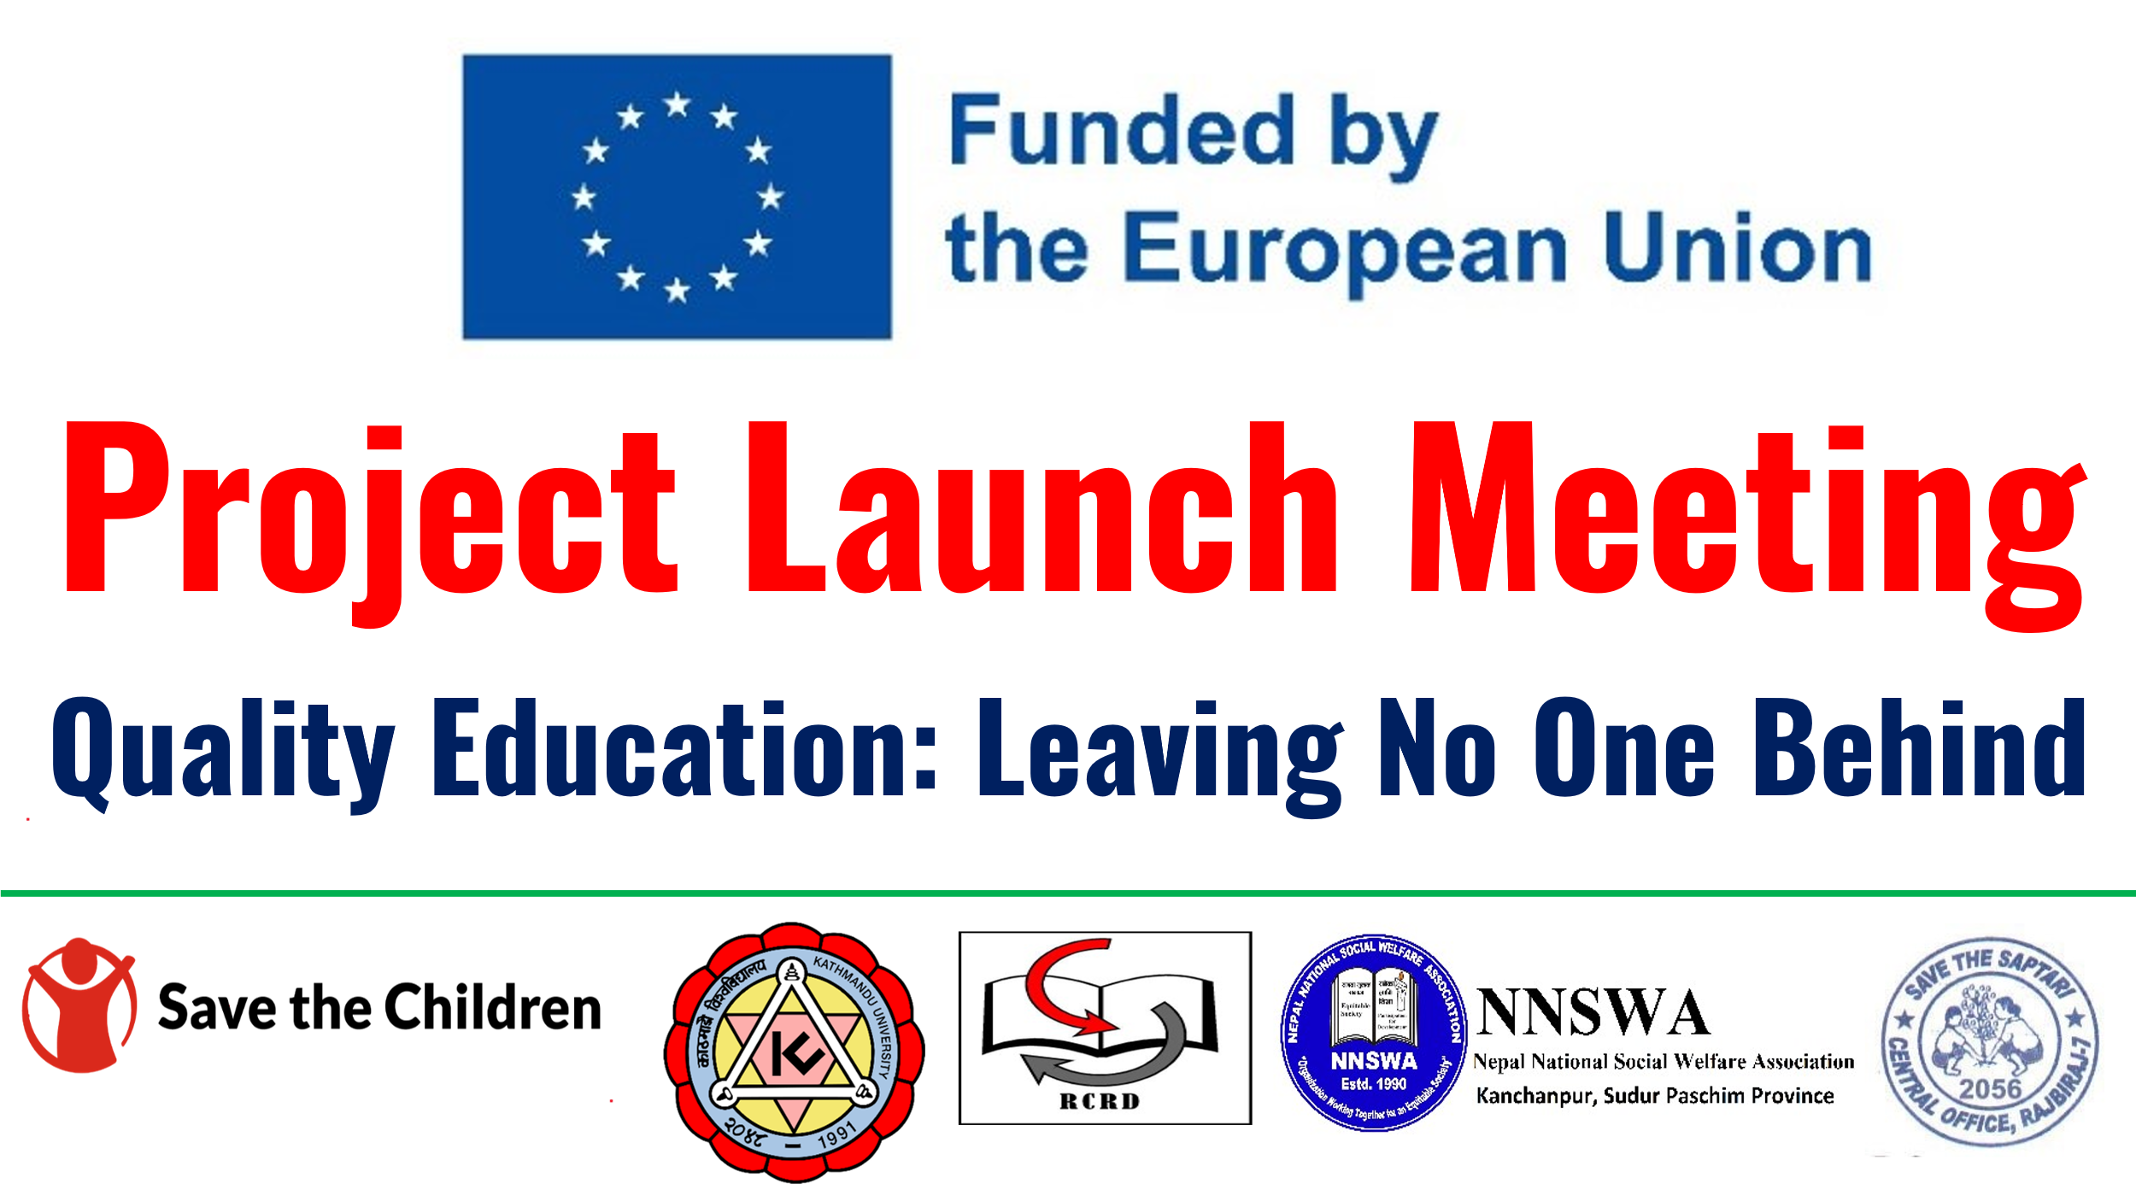
To ensure the visibility of the European Union (EU) support, the project has consistently highlighted EU support across all activities, including meetings, workshops, training sessions, and orientations. Banners displayed at these events clearly state that the project is funded by the EU and feature the EU logo. This information is also verbally communicated at the start of each event. Additionally, a project two-pager has been developed in both English and Nepali, providing a brief overview of the project and prominently featuring the EU logo and funding acknowledgment.

The project collaborated with the Center for Education and Human Resource Development (CEHRD) to develop a Universal Design for Learning (UDL) flipbook and a disability resource book, both of which include the EU logo. These materials have been widely distributed to stakeholders and beneficiaries across the country. Additionally, child-led IEC materials were designed and printed on canvas, incorporating EU branding to enhance outreach efforts. To further promote EU visibility, the project also produced jackets featuring the EU logo and project name.

EU visibility has been reinforced during key observances such as International Disability Day and Child Rights Day. Messages and updates from EU partner meetings and special day celebrations were regularly shared across the organization’s official social media channels, including Facebook, X (formerly Twitter), Instagram, and LinkedIn. These platforms have been instrumental in showcasing project achievements, milestones, and success stories, effectively highlighting the EU’s contribution to promoting equitable and quality education.

Furthermore, EU branding has been maintained in all official project communications. Calls for proposals (such as FSTP, vacancies, and consultancy opportunities), letters to stakeholders and beneficiaries, and invitations for meetings, training, and workshops clearly state that the project is EU-funded and prominently display the EU logo. All events are branded in accordance with EU visibility guidelines, ensuring consistent acknowledgment of EU support throughout the project.

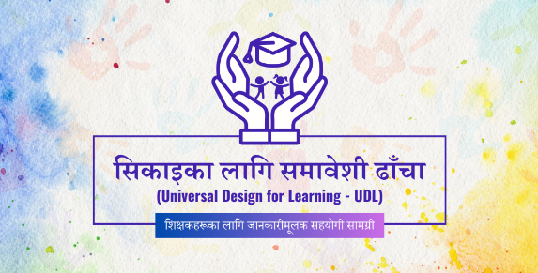 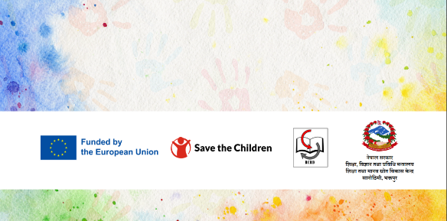niversal design for learning flip book developed in collaboration with CEHRD.
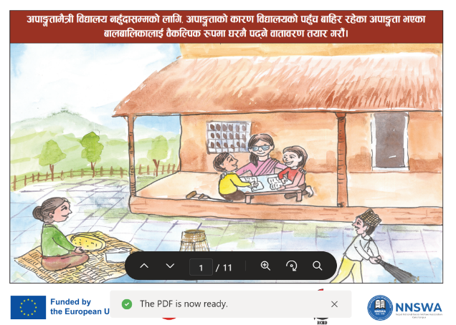 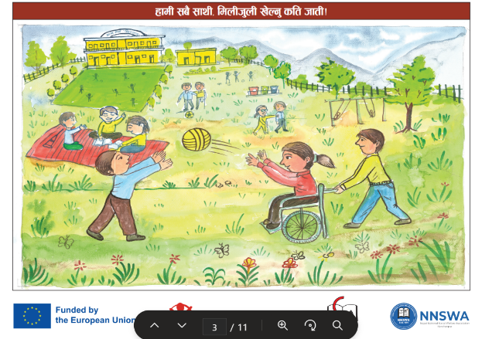 Children developed Information Education and Communication materials

Two Pager project Brief_english_for print.pdf - Project two pager

Link of media coverage:

Coverage | Link
Coverage of School at Home Program on National Kantipur Television | https://fb.watch/wZVJcIDiHv/  https://www.instagram.com/reel/DEhbXpVA_87/?utm_source=ig_web_copy_link

The European Commission may wish to publicise the results (impact, outcomes, outputs) of actions. Do you have any objection to this report being published on the EuropeAid website? If so, please state your objections here.

Name of the contact person for the action:

Bjørn- Richard Monsen

…….……………………………………………

Signature: ………………………………………

Location: …Oslo, Norway…….……………………

Date report due: ……14 May 2025………………..………….

Date report sent: ……14 May 2025……………………….

‘Target groups’ are the groups/entities who will be directly positively affected by the project at the project purpose level, and ‘final beneficiaries’” are those who will benefit from the project in the long term at the level of the society or sector at large.
Chhalphal Chautari is a discussion forum for parents, where they come together to share challenges related to the education of children with disabilities, girls, Dalit, Janajati and marginalized families. Through this platform, parents identify issues and explore locally led solutions to ensure access to education for all. Government authorities and service providers are also invited to these discussions to listen to the concerns and respond accordingly.
Integrated Education Management Information System (IEMIS) is an online system developed by the Ministry of Education, Science and Technology (MoEST) to collect and report student data from schools. The system includes different sub-tab one of them is disability sub-tab for reporting data related to students with disabilities.
This plan will cover the financial period between the interim report and the next report.

