[ 2025-2027 KOICA CPP]

1. Activity Overview
Category | Description
Activity | 1.2.1. Installation of Water Pump Facilities  Report on "Household Selection Report"
Date/time | 15th November
Place | 3 and 5 number Wards of Chhinnamasta
Person in Charge | HFHN:  Trainer: Mithlesh Yadav
Participants | Total 50 (male:48 and female: 2)

2. Activity Reporting
 | Activity  Description | Altogether, 50 households were selected out of the 115 households surveyed for support with hand pumps, following a comprehensive wellbeing ranking assessment of the community. The survey was carried out across various toles such as Dhobiyahi, Orahan, and Domarahi/Musahari in Ward No. 3 of Chhinnamasta Rural Municipality. Similarly, in Ward No. 5 of Chhinnamasta, additional 6 households were identified and selected for support as part of the effort to control and contain the cholera outbreak reported in the first week of November.  During the assessment, families were categorized into three groups: extremely poor, poor, and middle-income. This classification was based on several criteria, including household size, level of food sufficiency from their own production, income sources, type and condition of housing, and the size of their landholdings.  This process ensured that the most vulnerable and deserving families were prioritized for hand pump support, contributing to improved access to safe drinking water within the community.
 | Main Achievement | - 50 HHs have been selected for the hand pump support  - Drilling completed- 48 hand pumps,  - Ongoing drilling- 2 hand pumps  - Water quality tests completed- 6 hand pumps  - Bathroom under construction- 10 (completed super structures)
 | Challenges and counter measures | (Challenges and possible problem)  - Right beneficiary but limited/ no space for hand pump drilling
 | Challenges and counter measures | (Counter measures)  - Installed shared hand pump for families with limited space.
4. Indicators of wealth stratification
Indicators of wealth stratification | Total Scoring
Extremely poor families: families whose production is less than 3 months, unemployed, wage laborers, forced to live in mud or bush houses | Less than 1
Poor family: A family whose income is enough to feed them for 6 months, has a normal job, and has a moderate-sized home. | 1 to 3
Middle-class family: one whose income is enough to feed them for 9 months, has a job below the official level, and has a middle-class home. | 3 to 5
Wealthy family: One who can earn enough income from their own production to feed themselves for the whole year, has a business or industry, has an official-level job or higher, or receives a pension, and has a semi-detached or pucca house. | More than 5

5. Criteria |  |  |  |  |  |  |  |  |  |  |  |  | Total Scoring
  Criteria | Scoring | Calculation
  Ideal Family Size=5 | >5 = Minimum Score | (5-T_family)/5
  Ideal Family Size=5 | <5 = Maximum Score | (5-T_family)/5
  Food sufficient by own production | <=3 month=0  <=6 month=2  <=9 month=4  <=12 month=6 | IF(K5<=3,0,IF(K5<=6,2,IF(K5<=9,4,  IF(K5<=12,6,""))))
  Daily wage labour | Family ratio with labour wage | #of family labour/T_family#
  Simple Job=1  Job less than Officer=1  Business=3  Job greater than Officer=3  Pansenor=2  Abroad job=3 | simple job-1 to High job-3 | Sum of all the column(simple job: abroad job)
  House Type  Thatched or shack-Jhupro  Medium-sized house  RCC or Semi-building | Thatched or shack-Jhupro =0  Medium-sized house =2  RCC or Semi-building =4 | IF(W5="Thatched or shack-Jhupro",0,  IF(W5="Medium-sized house",2,  IF(W5="RCC or Semi-building",4,"")))
  Ideal land holding size=100 dhur(5 Kattha) | <100 = Minimum Score | (T_holding land by family)/100
  Ideal land holding size=100 dhur(5 Kattha) | >100 =Maximum Score | (T_holding land by family)/100

5. List of Selected Households
SN | Name of Household Head | Address | Sex (M/F) | Age | Marital Status (married/ single) | Family member |  |  | Disability Status (Yes/ No) | Caste/ Ethnicity
 |  |  |  |  |  | M | F | Total | Disability Status (Yes/ No) | Caste/ Ethnicity
1 | Rajo Sada | Chhinnamasta-3 | M | 42 | Married | 2 | 3 | 5 | No | Dalit
2 | Shivshankar Sada | Chhinnamasta-3 | M | 38 | Married | 3 | 1 | 4 | No | Dalit
3 | Jayshankar Sada | Chhinnamasta-3 | M | 36 | Married | 4 | 2 | 6 | No | Dalit
4 | Ramchandra Sada | Chhinnamasta-3 | M | 42 | Married | 2 | 1 | 3 | No | Dalit
5 | Laldev Sada | Chhinnamasta-3 | M | 40 | Married | 3 | 2 | 5 | No | Dalit
6 | Hirdev Sada | Chhinnamasta-3 | M | 38 | Married | 4 | 5 | 9 | No | Dalit
7 | Hasani Sada | Chhinnamasta-3 | M | 63 | Married | 4 | 3 | 7 | No | Dalit
8 | Magha Sada | Chhinnamasta-3 | M | 42 | Married | 3 | 2 | 5 | No | Dalit
9 | Balram Sada | Chhinnamasta-3 | M | 45 | Married | 4 | 3 | 7 | No | Dalit
10 | Gangaram Sada | Chhinnamasta-3 | M | 48 | Married | 2 | 3 | 1 | No | Dalit
11 | Parmeshwar Sada | Chhinnamasta-3 | M | 72 | Married | 3 | 3 | 6 | No | Dalit
12 | Jaylal Chaudhary | Chhinnamasta-3 | M | 68 | Married | 3 | 7 | 10 | No | Dalit
13 | Rama Sah | Chhinnamasta-3 | M | 37 | Married | 3 | 7 | 8 | yes | Madhesi
14 | Amir Sada | Chhinnamasta-3 | M | 36 | Married | 2 | 4 | 6 | No | Dalit
15 | Mukhiya Sada | Chhinnamasta-3 | M | 52 | Married | 4 | 2 | 6 | No | Dalit
16 | Laxman Sah | Chhinnamasta-3 | M | 47 | Married | 2 | 5 | 7 | No | Dalit
17 | Baldev Sada | Chhinnamasta-3 | M | 51 | Married | 4 | 2 | 6 | No | Dalit
18 | Doma Sada | Chhinnamasta-3 | M | 50 | Married | 3 | 2 | 5 | No | Dalit
19 | Rajendra Sada | Chhinnamasta-3 | M | 63 | Married | 2 | 2 | 4 | No | Dalit
20 | Satan Sada | Chhinnamasta-3 | M | 54 | Married | 2 | 2 | 4 | No | Dalit
21 | Palta Sada | Chhinnamasta-3 | M | 58 | Married | 4 | 4 | 8 | No | Dalit
22 | Opendra Sada | Chhinnamasta-3 | M | 40 | Married | 4 | 8 | 12 | No | Dalit
23 | Jethu Sada | Chhinnamasta-3 | M | 39 | Married | 2 | 1 | 3 | No | Dalit
24 | Kohi Sada | Chhinnamasta-3 | M | 54 | Married | 5 | 3 | 8 | No | Dalit
25 | Shiva sada | Chhinnamasta-3 | M | 45 | Married | 2 | 3 | 5 | No | Dalit
26 | Bhola Sada | Chhinnamasta-3 | M | 40 | Married | 3 | 2 | 5 | No | Dalit
27 | Rohit Sada | Chhinnamasta-3 | M | 28 | Married | 2 | 4 | 6 | No | Dalit
28 | Raju Sada | Chhinnamasta-3 | M | 27 | Married | 2 | 2 | 4 | No | Dalit
29 | Shyam Sundar Sada | Chhinnamasta-3 | M | 45 | Married | 3 | 2 | 5 | No | Dalit
30 | Bhogindra sada | Chhinnamasta-3 | M | 46 | Married | 3 | 4 | 7 | No | Dalit
31 | Bhupen Sada | Chhinnamasta-3 | M | 40 | Married | 2 | 4 | 6 | No | Dalit
32 | Shifta Sada | Chhinnamasta-3 | M | 49 | Married | 4 | 3 | 7 | No | Dalit
33 | Bechan Sada | Chhinnamasta-3 | M | 70 | Married | 4 | 7 | 11 | No | Dalit
34 | Nemanti Sada | Chhinnamasta-3 | M | 74 | Married | 3 | 4 | 7 | No | Dalit
35 | Rambilash Sada | Chhinnamasta-3 | M | 58 | Married | 3 | 2 | 5 | No | Dalit
36 | Ganu Sada | Chhinnamasta-3 | M | 72 | Married | 2 | 2 | 4 | No | Dalit
37 | Budhai Sada | Chhinnamasta-3 | M | 69 | Married | 3 | 5 | 8 | No | Dalit
38 | Satan Sada | Chhinnamasta-3 | M | 67 | Married | 4 | 4 | 8 | No | Dalit
39 | Tikhari Sada | Chhinnamasta-3 | M | 73 | Married | 7 | 4 | 11 | No | Dalit
40 | Narayan Sada | Chhinnamasta-5 | M | 45 | Married | 4 | 5 | 9 | No | Dalit
41 | Bindeswar Sada | Chhinamasta-5 | M | 56 | Married | 4 | 5 | 9 | No | Dalit
42 | Devji Sada | Chhinnamasta-5 | M | 45 | Married | 4 | 5 | 9 | No | Dalit
43 | Ramchandra Sada | Chhinnamasta-5 | M | 45 | Married | 6 | 6 | 12 | No | Dalit
44 | Bipin Sada | Chhinnamasta-5 | M | 38 | Married | 3 | 3 | 6 | No | Dalit
45 | Rajendra Sada | Chhinnamasta-5 | M | 60 | Married | 5 | 7 | 12 | No | Dalit
46 | Pathla Sada | Chinnamasta-3 | M | 48 | Married | 1 | 2 | 3 | No | Dalit
47 | Sabitri Sada | Chinnamasta-3 | F | 70 | Married | 6 | 8 | 14 | No | Dalit
48 | Dilip Sada | Chinnamasta-3 | M | 45 | Married | 3 | 2 | 5 | No | Dalit
49 | Sahadev Sada | Chinnamasta-3 | M | 65 | Married | 5 | 11 | 16 | No | Dalit
50 | Shanti Sada | Chinnamasta-3 | F | 55 | Married | 5 | 4 | 9 | No | Dalit
Total: 50 (male: 48 and female: 2)

6. Follow-up plan
- Ensure the installation of 50 hand pumps,
- Ensure safe water to each household,
- Ensure bathroom and soak-pit etc.

4. Photos (during wellbeing survey and selected HHs)
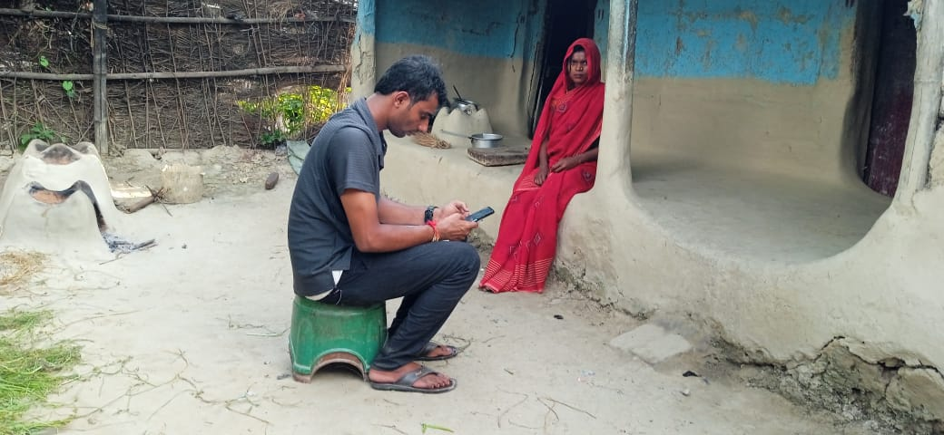 | 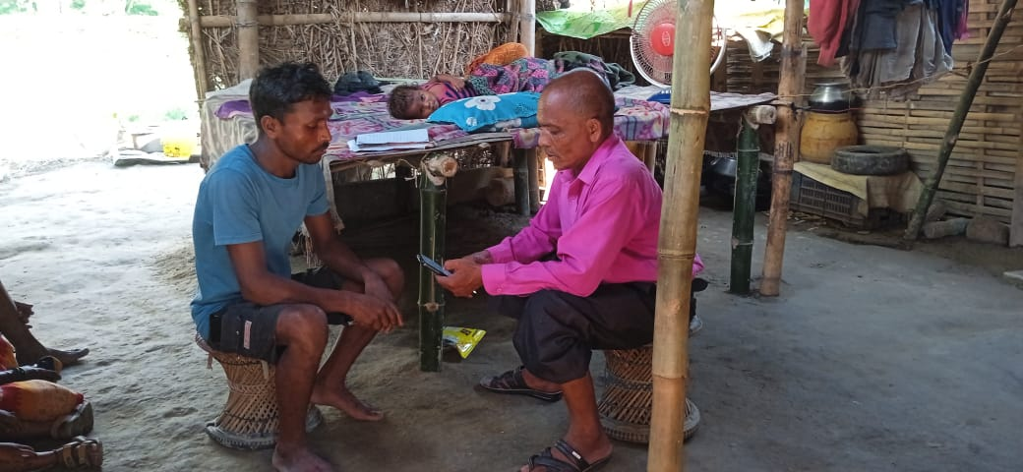
Wellbeing data collection using KoBo tool by SM | Wellbeing data collection using KoBo tool by SM
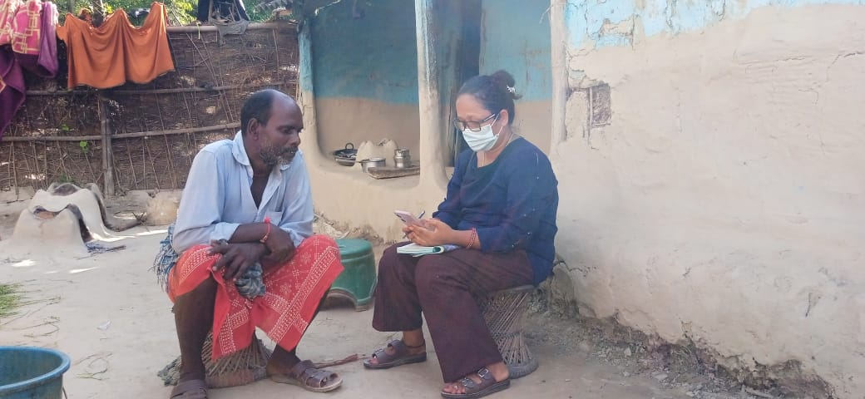 | 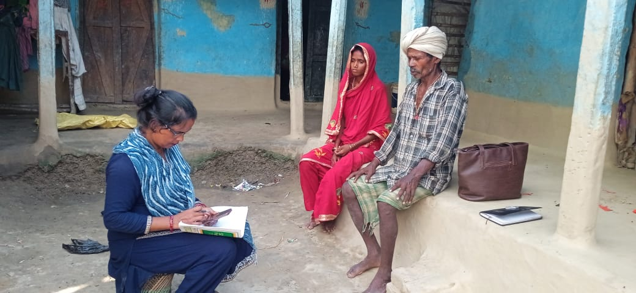
Wellbeing data collection using KoBo tool by SM | Wellbeing data collection using KoBo tool by SM
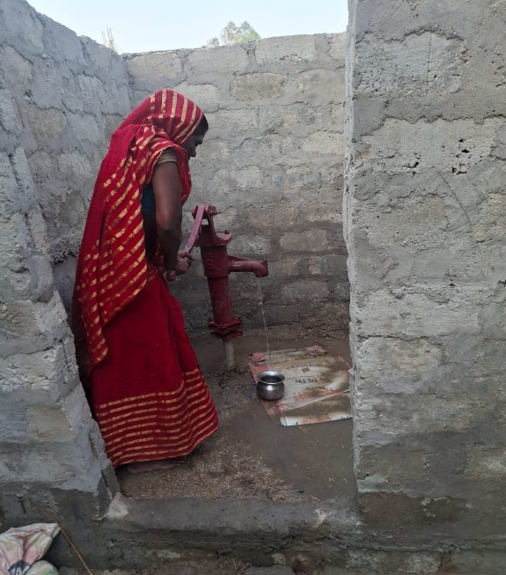 | 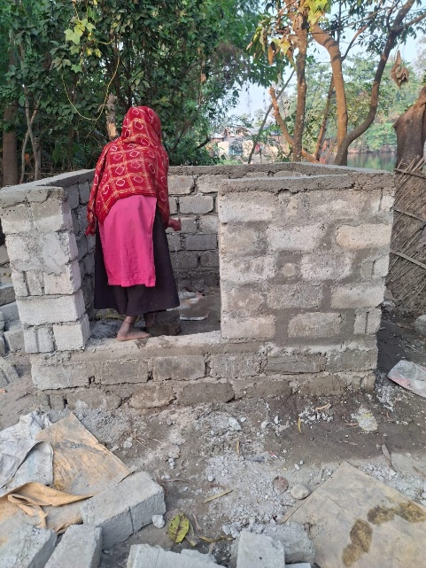
Hand pump with bathroom- deconstruction | Hand pump with bathroom- deconstruction
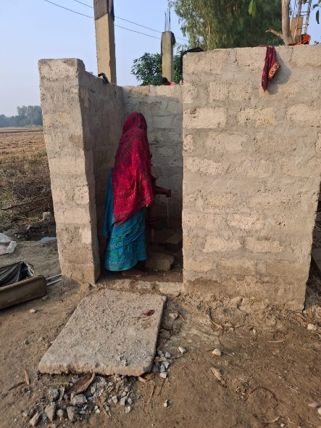 | 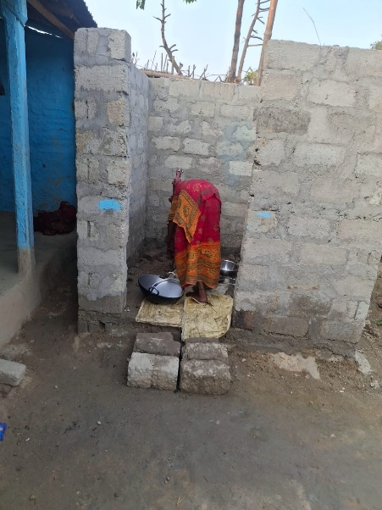
Hand pump with bathroom- deconstruction | Hand pump with bathroom- deconstruction

