[ 2025-2027 KOICA CPP]

1. Activity Overview
Category | Description
Activity | 1.3.5. Provision of Cleaning Tools for Communal Cleanliness
Date/time | October 2025
Place | 7 Wards of Chhinnamasta Rural Municipality- 15 Village WASH Committees
Person in Charge | HFHN:  Trainer: Mithlesh Yadav/Social Mobilizer
Participants | Total: 146 (male: 59 and female: 87)Participants

2. Activity Reporting
Activity  Description | A total of 15 Village WASH Management Committees were provided with comprehensive cleanliness kits to strengthen community-level sanitation efforts. Each committee received a complete set of essential cleaning tools and materials designed to support regular hygiene and environmental sanitation activities within their respective communities.  The kits were formally handed over to the Village WASH Management Committees in the presence of the Ward Chairpersons from each ward, ensuring transparency, community ownership, and local government engagement in promoting improved sanitation practices.  List of cleanliness Materials provided to each Village WASH MC  List of Logistic Materials provided to each Village WASH MC  Use and storage status:  The supplied materials are being safely managed under the supervision of each respective Village WASH Management Committee, with primary responsibility entrusted to the Committee Chairperson. Following the handover, the committees have begun mobilizing their members to organize and conduct regular cleanliness campaigns within their designated clusters. These initiatives are helping to promote improved hygiene practices, enhance community participation, and maintain a cleaner and healthier environment at the local level.
  S.N | Supported Items | Unit | Quantity
  1 | Broom (Coconut Jharu) | Pc | 10
  2 | Savel (Belcha) | Pc | 4
  3 | Spade with handle | Pc | 4
  4 | Dustpan (medium) | Pc | 10
  5 | Soap (handwashing-100 gm) | Pc | 5
  6 | Loose Gloves | Pkt. | 2
  7 | Surgical Mask | Pkt. | 3
  S.N | Supported Items | Unit | Quantity
  1 | Register | Pc | 1
  2 | Ball pen | Pc | 2
  3 | Newsprint | Pc | 15
  4 | Stamp pad | Pc | 1
  5 | Permanent Marker | Pc | 6
  6 | Masking Tape | Pc | 1
  7 | Toolbox | Pc | 1
  8 | Tarpaulin (double coated) | Pc | 2
  Vill. No. | Name of person keeping materials | Designation | Used Dates (2025)
  Vill-1 | Bina Devi Ram | Coordinator | 12th October
  Vill-2 | Shibu Kumar Khang | Coordinator | 12th October
  Vill-3 | Birendra Rajak | Coordinator | 15th October
  Vill-4 | Bindeshwar Sada | Coordinator | 18th October
  Vill-5 | Arun Chaudhary | Coordinator | 18th October
  Vill-6 | Manoj Kumar Jha | Coordinator | 12th October
  Vill-7 | Nunu Mukhiya | Coordinator | 12th October
  Vill-8 | Debram Sharma | Coordinator | 12th October
  Vill-9 | Dhana Kumari Sharma | Coordinator | 11th October
  Vill-10 | Gita Devi Sada | Coordinator | 20th October
  Vill-11 | Rekha Kumari Khang | Coordinator | 1st November
  Vill-12 | Laldev Sada | Coordinator | 16th October
  Vill-13 | Devnarayan Sada | Coordinator | 16th October
  Vill-14 | Shyam Sundar Rajak | Coordinator | 18th October
  Vill-15 | Lalit Mansuri | Coordinator | 18th October
Main Achievement | - 15 Village WASH Management Committees received cleanliness kits.  - Conducted 1 time community-led cleanliness activities.  - Developed ownership among the villagers.
Challenges and counter measures | (Challenges and possible problems)  - Proper use and safe handling of the materials
Challenges and counter measures | (Counter measures)  - Regular supervision of materials from the SM- storage and use,  - Develop ownership among the V WASH MC members etc.

4. Follow-up plan
- Conduction of monthly cleanliness activity
- Ensure the proper use of provided materials with regular supervision and monitoring.
- Check the status of the provided materials by senior officials etc.

5. Photos- Materials Handover
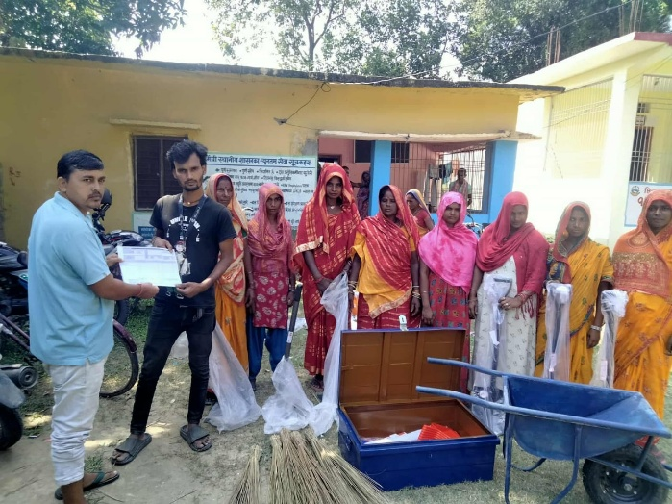 | 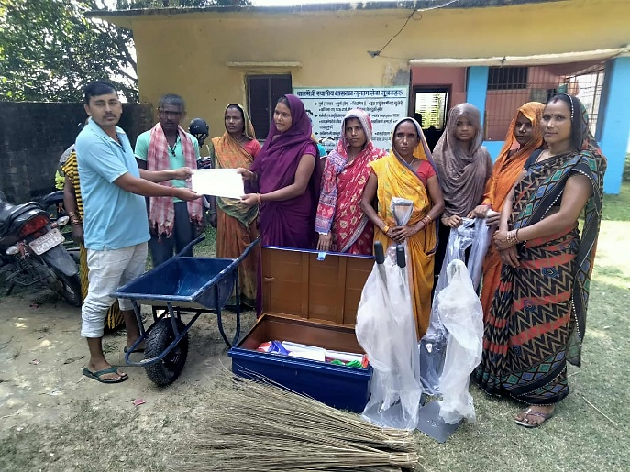
Ward-1, Birpur Ram Tole | Ward-1, Barhi Khang Tole
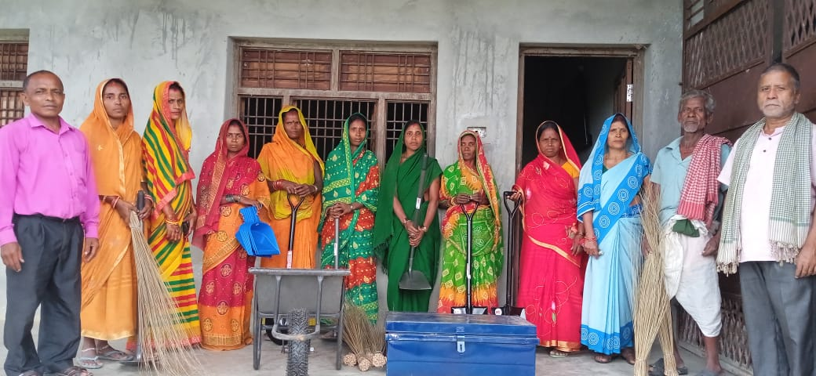 | 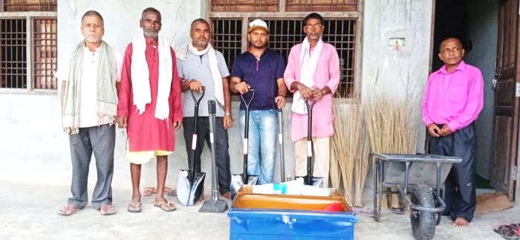
Ward-2, Mahuwa Safi Tole | Ward-2, Rampura Sada Marik Tole
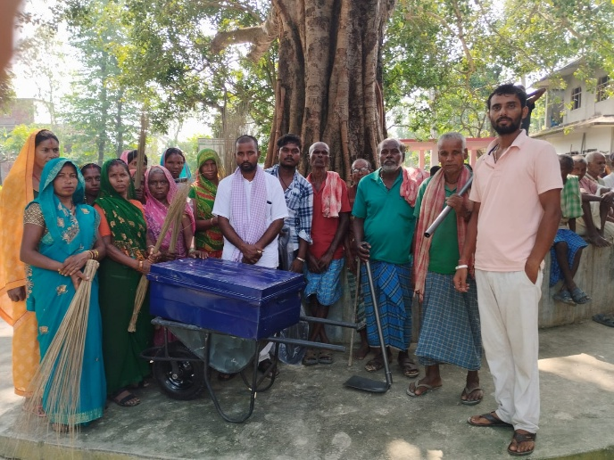 | 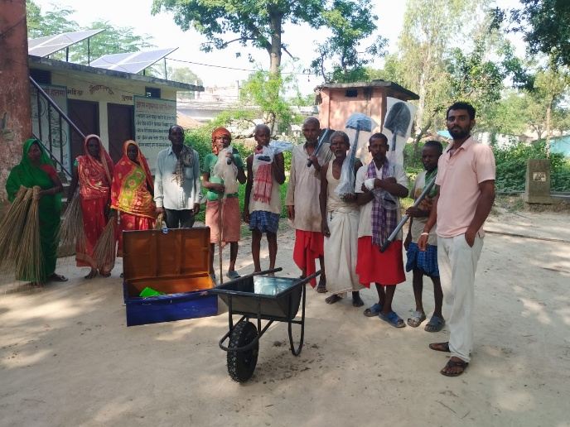
Ward-3, Govindpur Sada Tole | Ward-3, Sakhda Dhobiyahi Tole
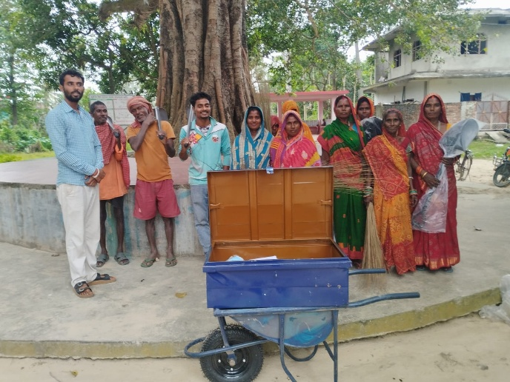 | 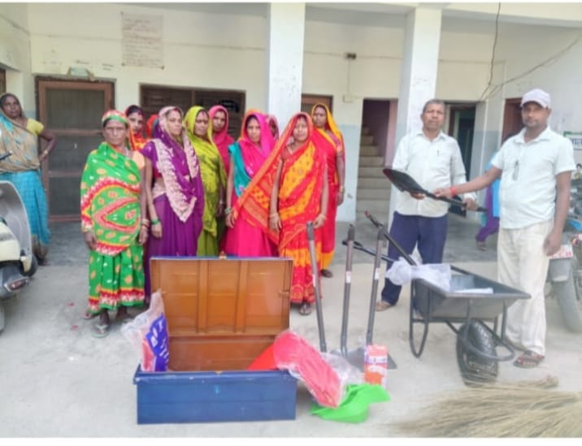
Ward-3, Sakhda Orhan Tole | Ward-4, Lalapatti Ram Tole
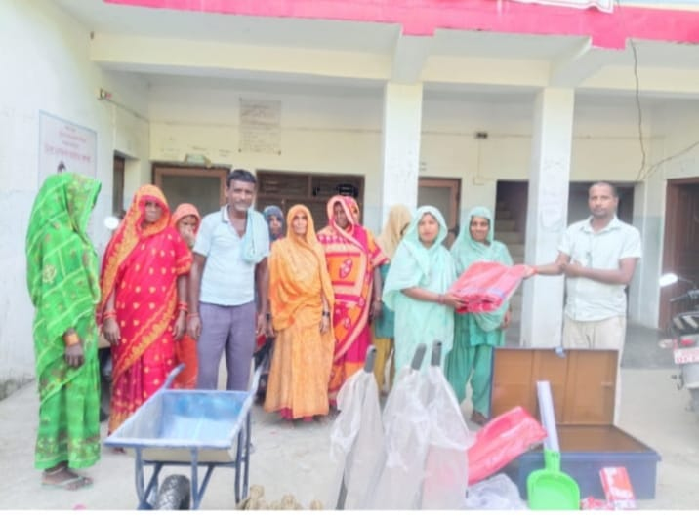 | 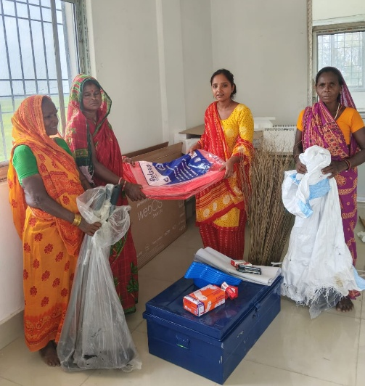
Ward-4, Lalapatti Khang Muslim Tole | Ward-5, Lokhram Khang Tole
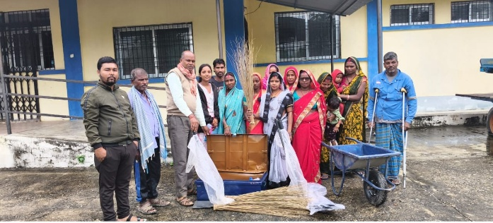 | 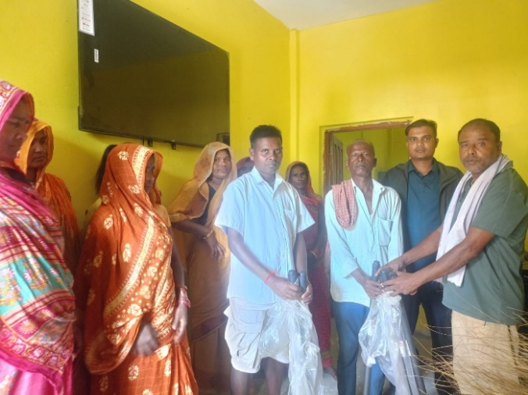
Ward-5, Lokhram Sada Tole | Ward-6, Kochabakhari Sada marik Tole
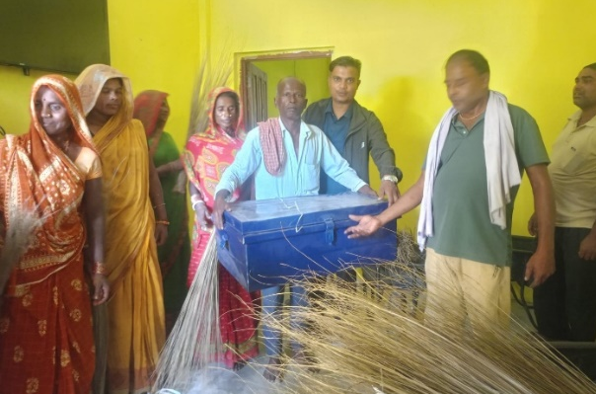 | 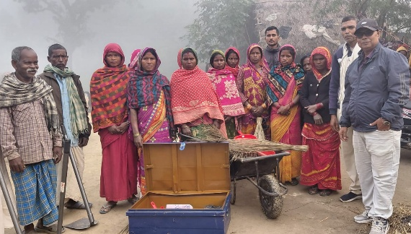
Ward-6, Kochabakhari Sada Tole | Ward-7, Hatti Sada Tole
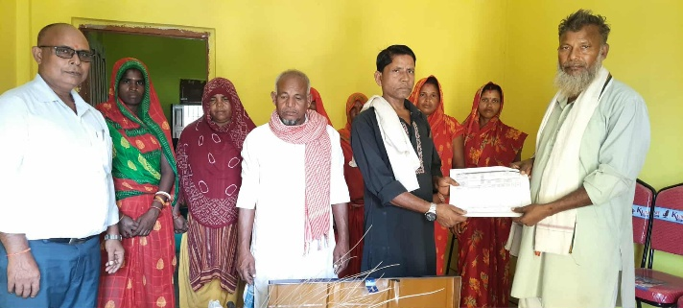
Ward-7, Hatti Sada Muslim Tole

