[ 2025-2027 KOICA CPP]

1. Activity Overview
Category | Description
Activity | Youth Volunteer Monthly Meeting
Date/time | 29th Oct. 2025 (for the month of October 2025)
Place | Palika Hall Chhinnamasta-3, Sakhda
Person in Charge | HFHN:  Trainer: Project Coordinator
Participants | Volunteers: 56 (male: 27 and female: 29)  StS Staff: 11 (male: 8 and female: 3)
SN | Name of Volunteer | Address | Sex |  | Disablity Status | Caste/Ethnicity
SN | Name of Volunteer | Address | M | F | Disablity Status | Caste/Ethnicity
1 | Nitu Ray | Chhinamasta-1 | - | 1 | No | Madheshi-others
2 | Sanju Kumari Yadav | Chhinamasta-1 | - | 1 | No | Madheshi-others
3 | Manisha Kumari Ram | Chhinamasta-1 | - | 1 | No | Dalit
4 | Kabiat Kuamri Yadav | Chhinamasta-1 | - | 1 | No | Madheshi-others
5 | Rahul Kumar Ray | Chhinamasta-1 | 1 | - | No | Madheshi-others
6 | Ram Ray | Chhinamasta-1 | 1 | - | No | Madheshi-others
7 | Shivshankar Ray | Chhinamasta-1 | 1 | - | No | Madheshi-others
8 | Dipesh Kumar Ray | Chhinamasta-1 | 1 | - | No | Madheshi-others
9 | Sulochana Sah | Chhinamasta-2 | - | 1 | No | Madheshi-others
10 | Ajay Sah | Chhinamasta-2 | 1 | - | No | Madheshi-others
11 | Prity Marik | Chhinamasta-2 | - | 1 | No | Dalit
12 | Nitish Marik | Chhinamasta-2 | 1 | - | No | Dalit
13 | Sapna Jha | Chhinamasta-2 | - | 1 | No | Madheshi-others
14 | Anju Kumari Mandal | Chhinamasta-2 | - | 1 | No | Dalit
15 | Bijay Kumar Mandal | Chhinamasta-2 | 1 | - | No | Dalit
16 | Krishna Kumar Yadav | Chhinamasta-2 | 1 | - | No | Madheshi-others
17 | Shibu Kumari Mandal | Chhinamasta-3 | - | 1 | No | Dalit
18 | Ganga Pd Mandal | Chhinamasta-3 | 1 | - | No | Dalit
19 | Jitendra Sah | Chhinamasta-3 | 1 | - | No | Madheshi-others
20 | Rani Sharma | Chhinamasta-3 | - | 1 | No | Madheshi-others
21 | Sita Kumari Mandal | Chhinamasta-3 | - | 1 | No | Dalit
22 | Dependra Mandal | Chhinamasta-3 | 1 | - | No | Dalit
23 | Laxmi Devi Mallah | Chhinamasta-3 | - | 1 | No | Madheshi-others
24 | Kamlaesh Kumar Ram | Chhinamasta-3 | 1 | - | No | Dalit
25 | Ganesh Kumar Yadav | Chhinamasta-4 | 1 | - | No | Madheshi-others
26 | Sneha Yadav | Chhinamasta-4 | - | 1 | No | Madheshi-others
27 | Santosh Sharma | Chhinamasta-4 | 1 | - | No | Brahmin-Tarai
28 | Sunil Mandal | Chhinamasta-4 | 1 | - | No | Dalit
29 | Asha Kumari Mandal | Chhinamasta-4 | - | 1 | No | Dalit
30 | Nitesh Pandit | Chhinamasta-4 | 1 | - | No | Madheshi-others
31 | Ritu Kumari Yadav | Chhinamasta-4 | - | 1 | No | Madheshi-others
32 | Mithila Kumari Yadav | Chhinamasta-4 | - | 1 | No | Madheshi-others
33 | Puspa Sah | Chhinamasta-5 | - | 1 | No | Madheshi-others
34 | Shankar Kumar Mehta | Chhinamasta-5 | 1 | - | No | Madheshi-others
35 | Madan Kumar Khang | Chhinamasta-5 | 1 | - | No | Dalit
36 | Devkumar Kamait | Chhinamasta-5 | 1 | - | No | Madheshi-others
37 | Nanki Kumari Sharma | Chhinamasta-5 | - | 1 | No | Dalit
38 | Anjali Kumari Sah | Chhinamasta-5 | - | 1 | No | Madheshi-others
39 | Sanjay Kamat | Chhinamasta-5 | 1 | - | No | Madheshi-others
40 | Anubha Jha | Chhinamasta-5 | - | 1 | No | Madheshi ohters
41 | Rabin Kumar Thakur | Chhinamasta-6 | 1 | - | No | Dalit
42 | Chhina Kumari Mukhiya | Chhinamasta-6 | - | 1 | No | Madheshi-others
43 | Kabita Kumari Khang | Chhinamasta-6 | - | 1 | No | Dalit
44 | Sony Kumari Sah | Chhinamasta-6 | - | 1 | No | Madheshi-others
45 | Kabita Kumari Sah | Chhinamasta-6 | 1 | - | No | Madheshi-others
46 | Krishna Kumar Sah | Chhinamasta-6 | - | 1 | No | Madheshi-others
47 | Shankar Yadav | Chhinamasta-6 | 1 | - | No | Madheshi-others
48 | Permanand Ram | Chhinamasta-6 | 1 | - | No | Dalit
49 | Shankar Sada | Chhinamasta-7 | 1 | - | No | Dalit
50 | Sangita Yadav | Chhinamasta-7 | - | 1 | No | Madheshi-others
51 | Rajesh Kumar Yadav | Chhinamasta-7 | 1 | - | No | Madheshi-others
52 | Deepak Kumar Yadav | Chhinamasta-7 | 1 | - | No | Madheshi-others
53 | Puja Kumari Yadav | Chhinamasta-7 | - | 1 | No | Madheshi-others
54 | Babita Devi Rajak | Chhinamasta-7 | - | 1 | No | Dalit
55 | Pinki Devi Rajak | Chhinamasta-7 | - | 1 | No | Dalit
56 | Somi Kumari Yadav | Chhinamasta-7 | - | 1 | No | Madheshi-others
Total |  |  | 27 | 29
Save the Saptari Staff
57 | Mithlesh Yadav | PC | 1 | - | No | Madheshi-others
58 | Mahesh Chaudhary | AFO | 1 | - | No | Madheshi-others
59 | Love Bikram Yadav | Technical Coordinator | 1 | - | No | Madheshi-others
60 | Sunil Yadav | Technical Supervisor | 1 | - | No | Madheshi-others
61 | Kamala Mandal | SM | - | 1 | No | Madheshi-others
62 | Neha Das | SM | - | 1 | No | Madheshi-others
63 | Laxmi Baijnath | SM | - | 1 | No | Madheshi-others
64 | Badri Mandal | SM | 1 | - | No | Madheshi-others
65 | Kundan Chaudhary | SM | 1 | - | No | Madheshi-others
66 | Champalal Sharma | SM | 1 | - | No | Madheshi-others
67 | Ram Kumar Sah | SM | 1 | - | No | Madheshi-others
Total |  |  | 8 | 3

2. Activity Reporting
Activity  Description | A Youth Volunteers’ monthly meeting was held on 29 October 2025 at the Palika Hall, with a total of 67 (56 volunteers and 11 Save the Saptari staff) volunteers and staff participating.  Meeting Objective:  - To review updates on literacy group formation at the community level and the progress of baseline data collection  - To engage, encourage and appreciate volunteers for their efforts and discuss upcoming WASH plan activities  The meeting focused on reviewing the progress of literacy group formation in the community and assessing the ongoing baseline data collection process. Participants shared updates on their activities, highlighted challenges faced during group formation and discussed practical strategies to strengthen community engagement in literacy initiatives. Volunteers were also encouraged and acknowledged for their continued efforts in supporting WASH plan activities.  The volunteers openly expressed the difficulties encountered during the formation of literacy groups and jointly explored possible solutions and way forward. Additionally, the meeting provided further clarification on the WASH plan activities that volunteers are expected to organize in the coming days, ensuring better preparedness and coordination.
Main Achievement | - All 56 volunteers participated in the Volunteer monthly meeting.
Challenges and counter measures | (Challenge/potential problems)  - Keep them motivated
Challenges and counter measures | (Counter measures)  - Capacity building trainings for their motivation and skills development,  - Provide allowance timely,  - Motivation to work for their own community etc.

3. Follow-up plan
- Provide ToT on WASH to volunteers
- Conduct monthly meeting for November 2025
- Ensure their involvement in WASH session conduction at community level etc.
4. Photos
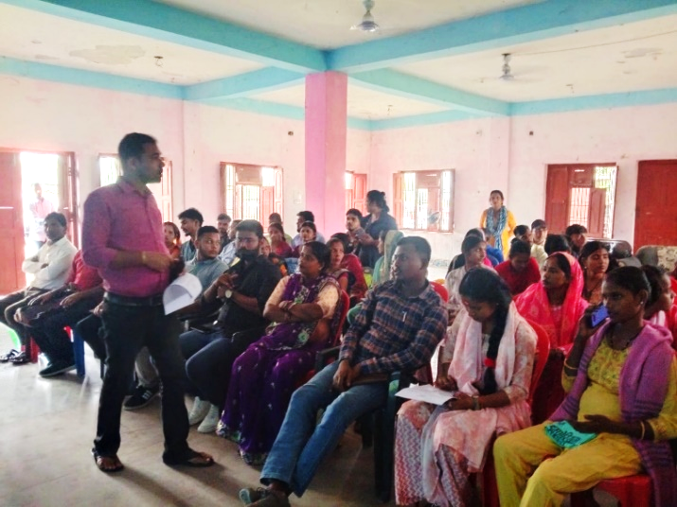
Project Coordinator interacting with the volunteers and team.

